voctomix controller hardware

design thoughts
- Controller oder Musikinstrument?
- some angels hit the buttons really hard, if you build the piece with pcb mounted buttons you might consider reinforcing that structure from below
- if it looks like an ATEM-switcher that confuses some people (like working on a keyboard with the wrong keyboard layout)

voctoknopf1 (nennemich)
- https://github.com/benjaminwand/voctoknopf1
- arduino based
- was used on 34c3
- todo: finish TCP implementation, build 5 more
- discontinued, device is with Masterbase
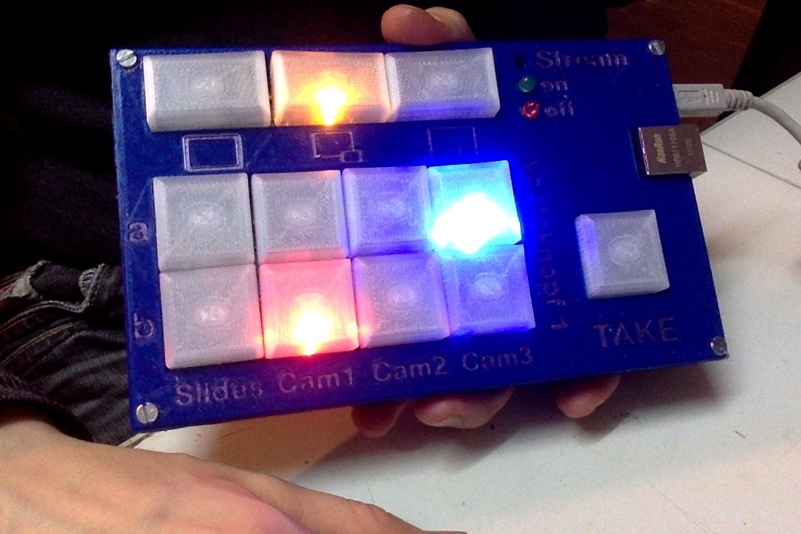

voctopanel (derpeter)
Based on an arduino and an adafruit trellis board, current status is prove of concept. The board will be connected to the machine running voctogui or could also be a separate device (i.g. arduino with ethernet shild or raspi)
Todos
- react on switching of sources / modes (will be done as soon as voctolight command handler is ready to be ported)
- write better arduino firmware
- 3D print a casing
- build 5 more
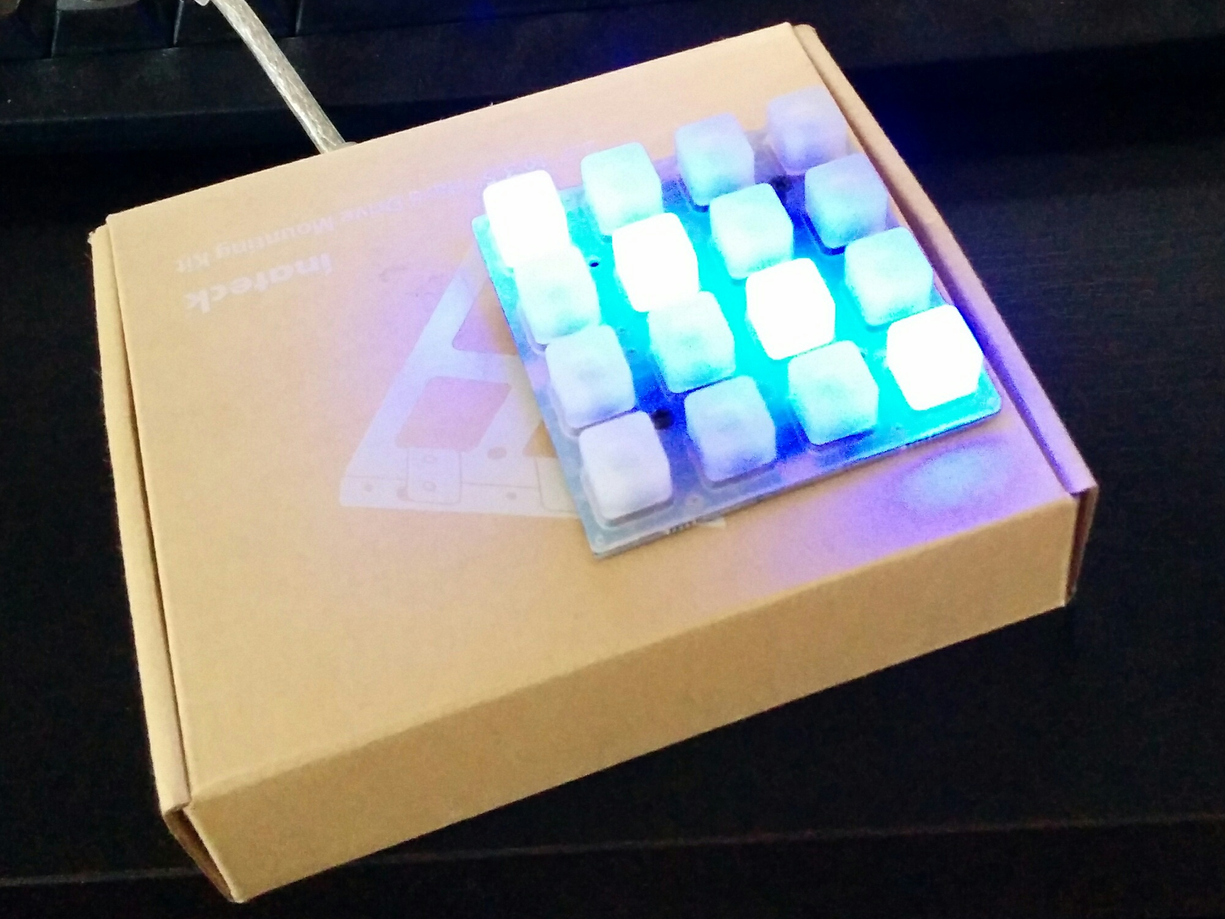

steam deck (derchris)
https://github.com/derchrisuk/voctomix-stream-deck
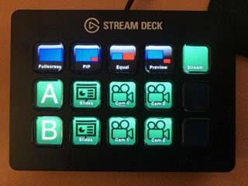

voctomix controller (nightvisi0n)
- mockup
  - https://github.com/nightvisi0n/voctomix-controller-mockup
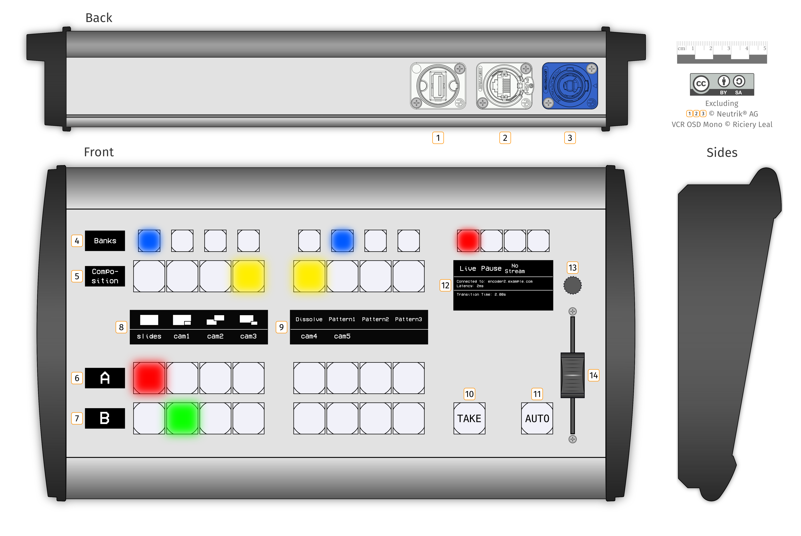https://github.com/nightvisi0n/voctomix-controller-mockup

voctoplay (nennemich)
https://github.com/benjaminwand/voctoplay
- mockup
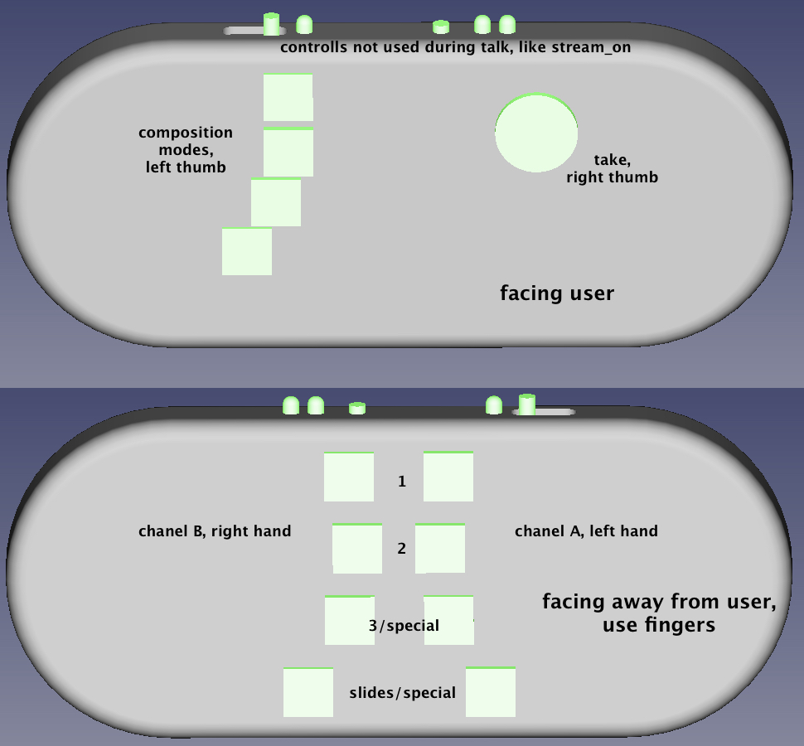
expected advantages:
- can't be confused with an ATEM switcher (if the voctopanel looks like an ATEM switcher that is like typing on the wrong keyboard layout for everyone who is used to an ATEM switcher interface, which is like everybody except very new mixer angels)
- chord typing (like steno) means you can be fast without getting stressed out
- small
- muscle memory works better when you have only one button per finger
- looks cool
- stream-on-button can't be confused
expected disadvantages:
- might be complicated with very large or very small hands, we'll have to test that approach 0.11 tried with several hands on January 16th at CCCB, adjustments were made, seems to be good compromise for 'all' hands now
- requires preview/selected
Discontinued, device is with Masterbase

