https://c3voc.de/wiki/_media/testbild_1080p.png

https://git.franzi.business/kunsi/infobeamer-testcard/src/branch/main/testcard.png
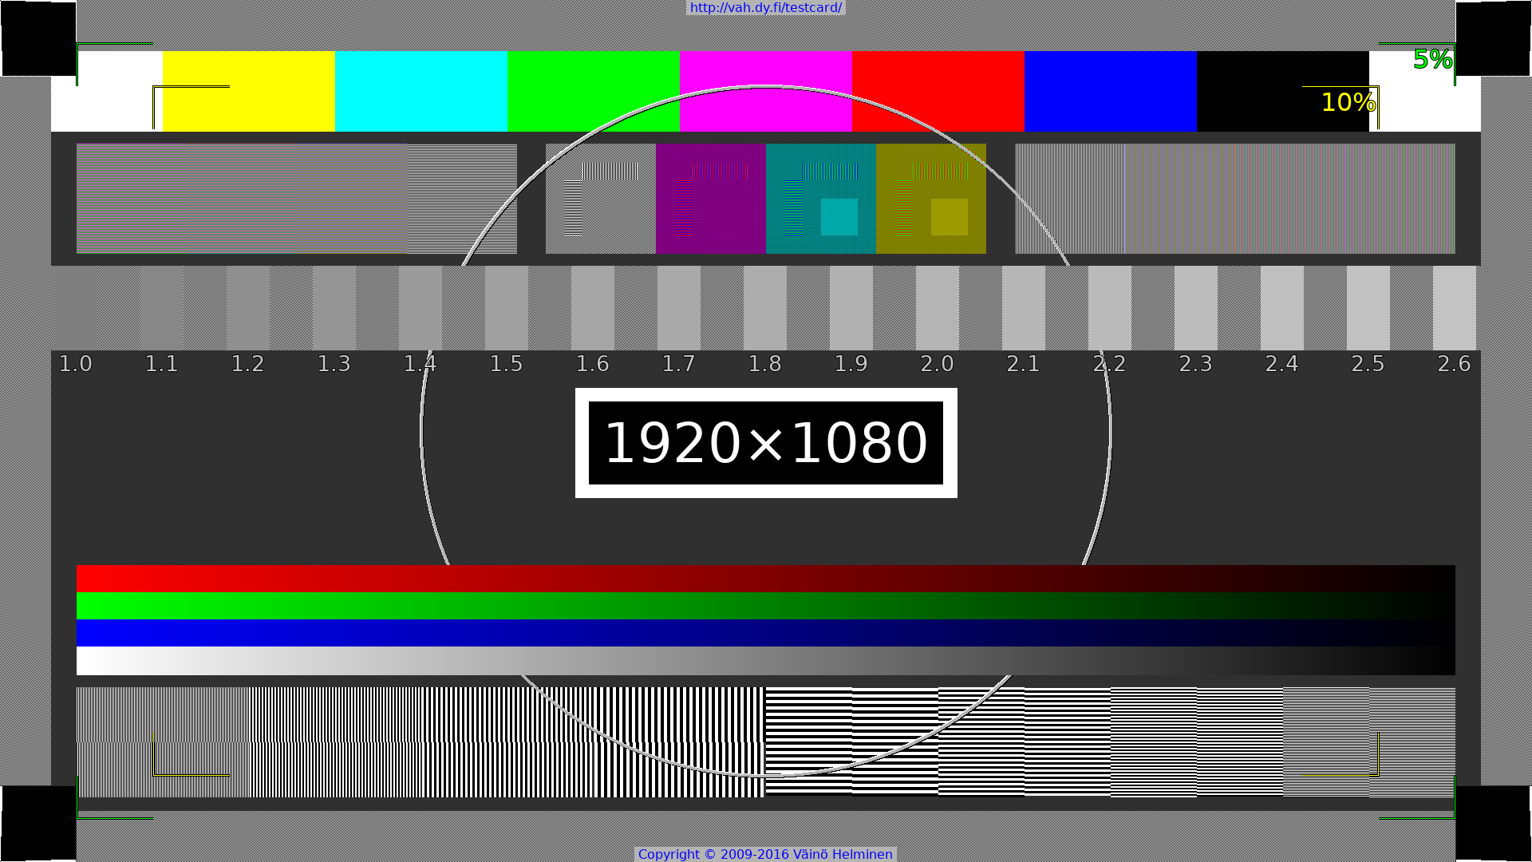
http://strkri.de/winkekatze/ 
http://dascritch.github.io/testcard.html/ https://github.com/dascritch/testcard.html 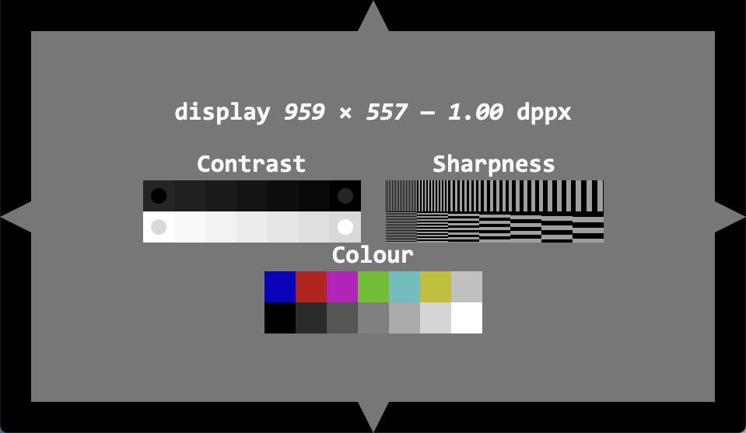
https://github.com/edent/SVGtestcard/ 

