= Subtitles / Untertitel
=== Architecture overview in context of media.ccc.de
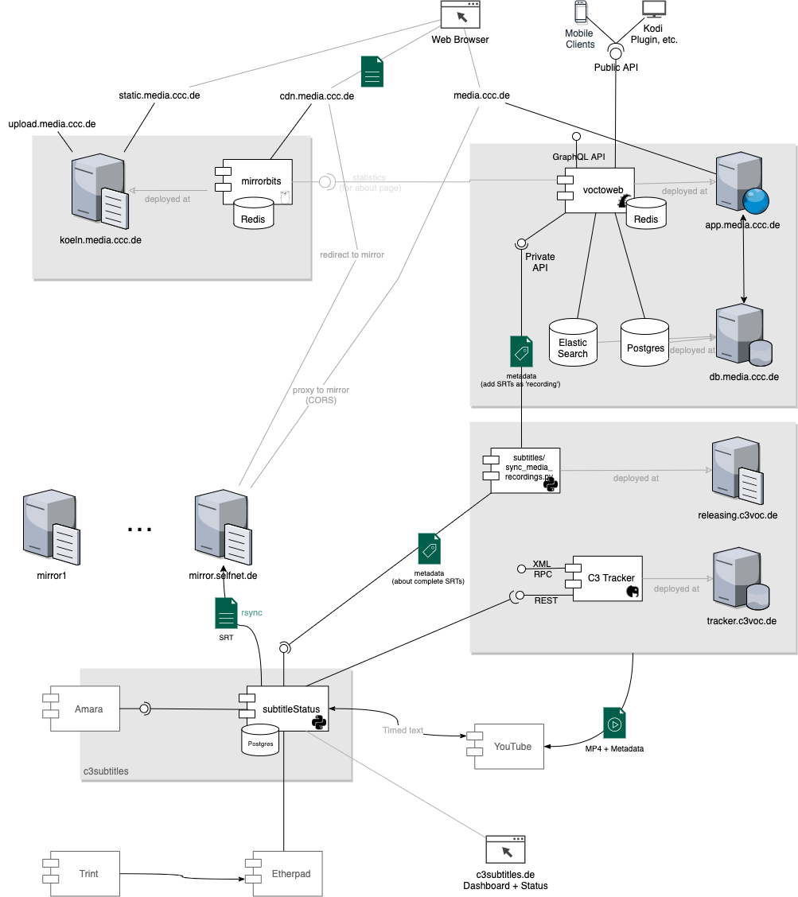
Achtung: Der Rest dieser Seite wird ggf. nicht mehr aktiv gepflegt. Das Team hat inzwischen eigene Infrastruktur: https://wiki.c3subtitles.de== Communication
- Web: https://c3subtitles.de/
- Twitter: www.twitter.com/c3subtitles
- Mailinglist: subtitles-angels -at- lists.selfnet.de
- Mailinglist: subtitles -at- lists.ccc.de
- IRC: #subtitles auf hackint. Requires SSL. - but also the #voc channel
- Etherpad-Domain: https://subtitles.pads.ccc.de
- Jabber: c3subtitles -!-at-!- jabber.ccc.de
- Videos on amara.org : c3subtitles videos on amara.org
- E-Mail: subtitles -!-at-!- c3voc.de
== What is our goal?
Better and more barrierfree access to the live talks and streams and to the videos afterwards via subtitles. Especially for non-natives of the spoken languages and for deaf and hard of hearing listeners.
Nice side effect: finished subtitles are pretty easy to translate in any other language, amara.org also provides a very easy usable interface for that purpose.
== How can I help?
- If you visit the congress and are a user of a speech recognition software, please contact us! Also if you are a computer stenography writer or a good touch typist.
- If you are interested in what we are working on behind the scenes, just contact us!
- Help us creating the subtitles via amara.org - you do not even have to visit the congress to do that! Everybody from at home can do that!
== What are our current projects behind the scenes?
- Devoloping software for a user interface to choose which subtitle you want to work on depending on your favorite task
- Developing software for subtitles via computer stenography or speech recognition, visible live in the talk via webstream and later as start for the precise version to work on in amara.org
- Developing a phonetic german steno keyboard layout
- Building a steno keyboard
- Using an old mechanical stenographer with a micro controller to detect the pressed keys as steno input
Intern

