Viri ESP
Viri-ESP is a ESP-32 based hardware project for making our alert system inside the VOC office easy to deploy when the voc2dmx hardware is not around. It should be found in the R2 box.
The source code for the ESP-IDF based version (the newer one) can be found on our git forge.
The old code for the platformio based version can be found here.

Hardware
The hardware itself is just a ESP-32 based devboard. There, a JST SM male connector is soldered onto the ESP-32 (red to VIN, white to GND, green to GPIO5). This way, the ESP can be powered via the LED strip.
If the strip is not 5V, do not connect the red wire to VIN!

Compatible LED strips
The first test of the hardware was doing GLT26. There we used a WS2812B 5V LED strip. While in theory with a bit of modifications the ESP-32 would of course work with ledstrips with higher voltage, 5V is ideal because it also is the right voltage for the ESP-32 devboards and is easily available through USB.
It is recommended to solder on a USB-C PD trigger pcb to the red and white wires of the LED strip on the start of the ledstrip. This way the ESP-32 is getting powered through the JST connector.

Web-UI
For basic operation, a webui is hosted both on the AP and STA interface.
Directly next to the page title, you can find a reboot button and a “Toggle viri handling” button. The latter is used to disable processing of the MQTT messages on /voc/alert-viri in case of excessive blinking. This is reverted by clicking the button again or rebooting the ESP-32.
Below that is a box with status information about the ESP-32. It shows uptime, the git-hash the of the flashed firmware and connectivity information.
After that there is a quick config section. Here you can change the brightness of the ledstrip, configure its length or change the wifi credentials.
While not required for basic operation, below that is a config explorer for all the config keys exposed by the firmware.
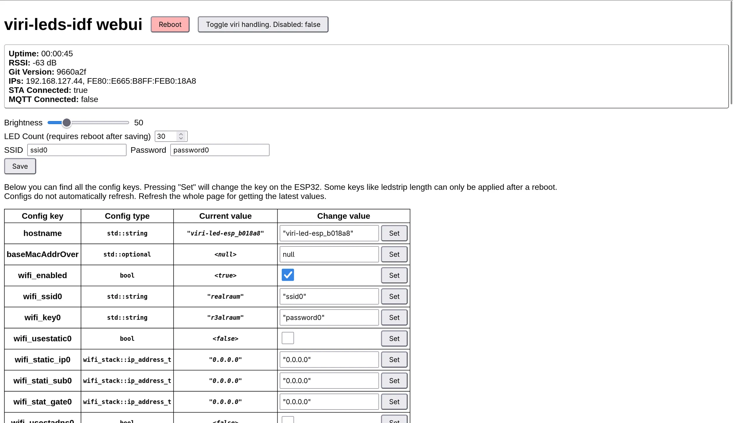Screenshot of the webui

Pictures
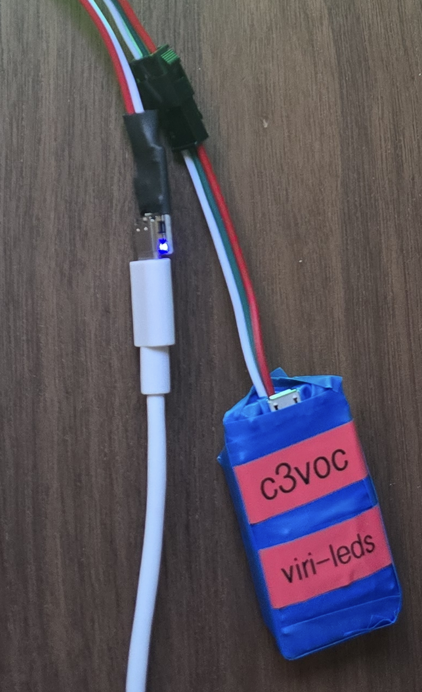Picture of the ESP-32 board

