QSC TouchMix-8

Main PCB
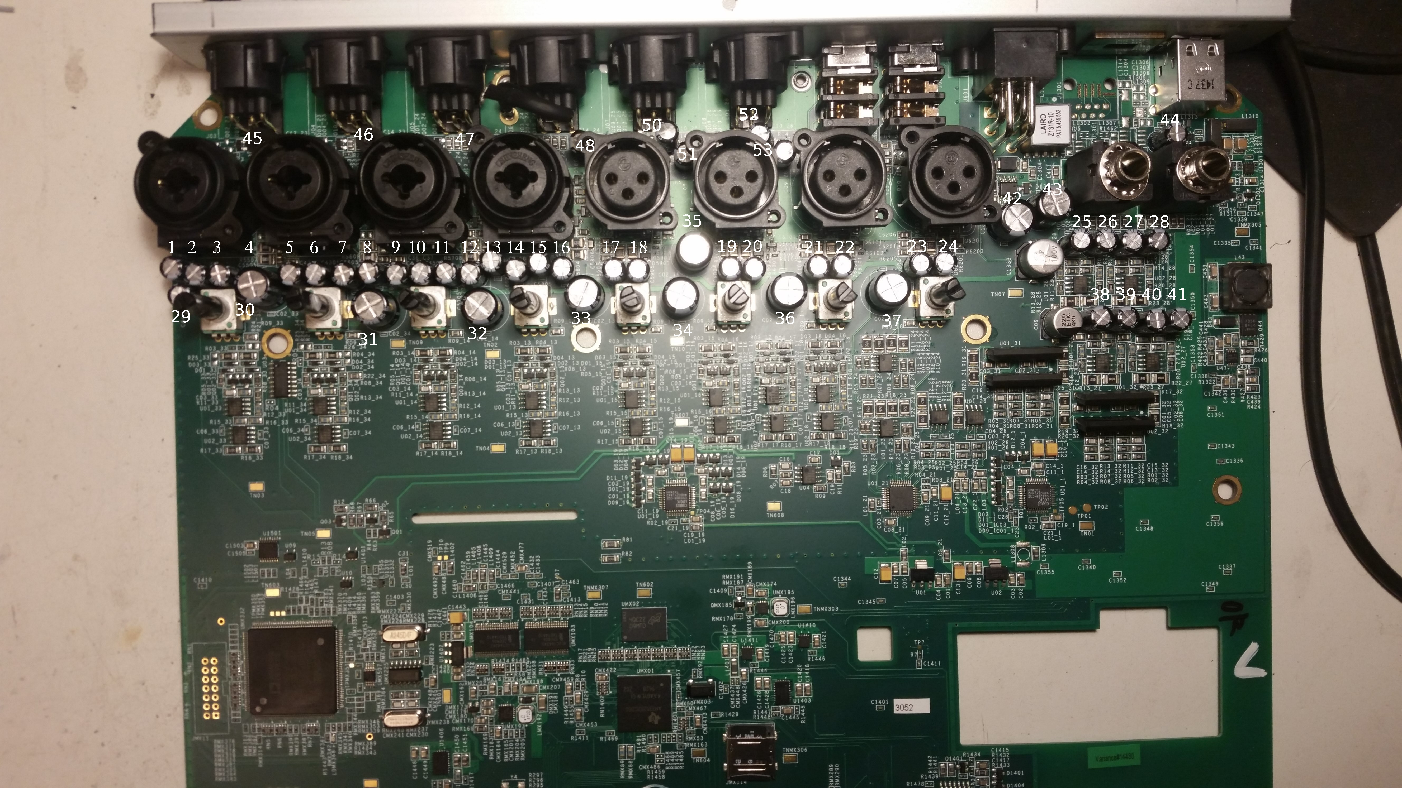
* 47 µF 63V 105C∘ 12*6,5mm (3mm pin): 1-3, 5-29, 38-41, 44-53
* 1000 µF 10V 85C∘ 13,5*10mm (5mm pin): 30-37
* 330 µF 25V 13,5*10mm (5mm pin): 42-43

Presets
There is a “VOC standard configuration”.Just unpack this to a FAT32 formatted USB drive and load the preset (some .qdx and .qdxhdr files inside a “TouchMix-Presets” folder): touchmix-presets.zip

