Server Case (C)
Detailed documentation of this case is kept in netbox and should be kept up to date:https://netbox.c3voc.de/dcim/racks/1/
This case contains hardware that should be placed at the event colo or another well connected place.
Measurements (guessed): Length 102cm, width 60cm, height 77cm.
Weight: ~140 kg
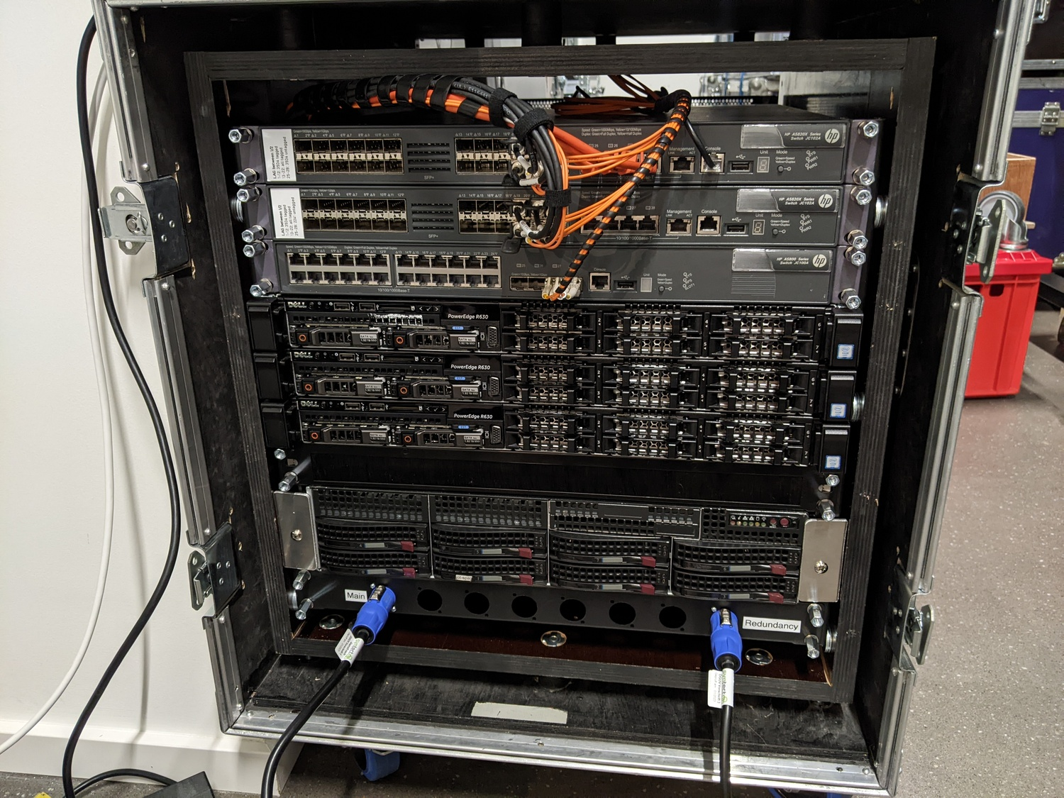Servercase front
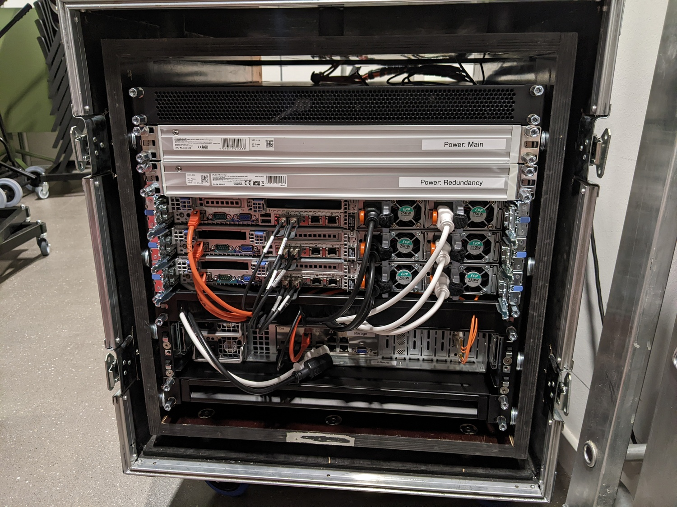Servercase back
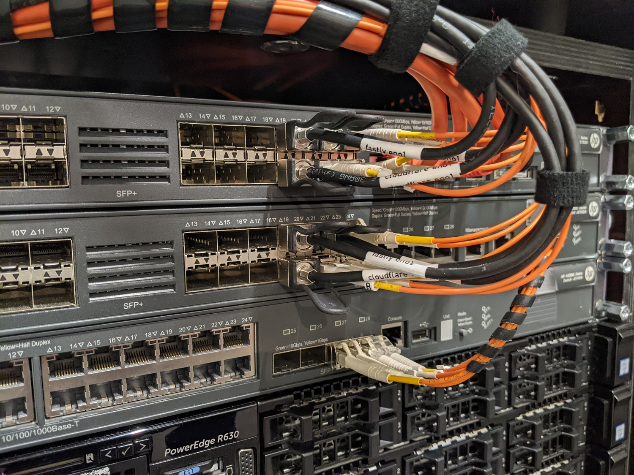Servercase, detail switch-connections
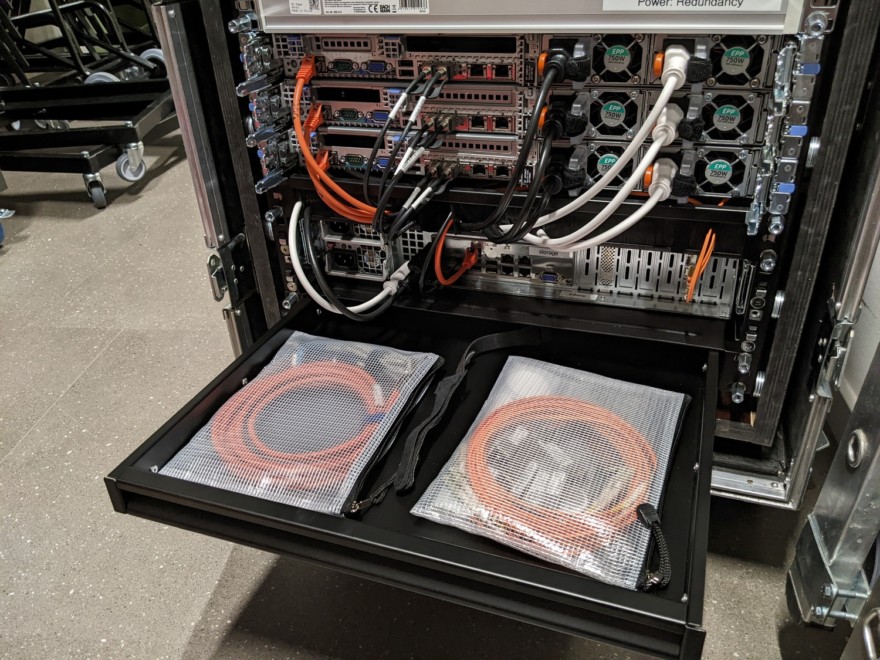Servercase, detail back with open drawer

