Video capture and encoding on the Raspberry pi
This page is currently a research collection and commands might not work
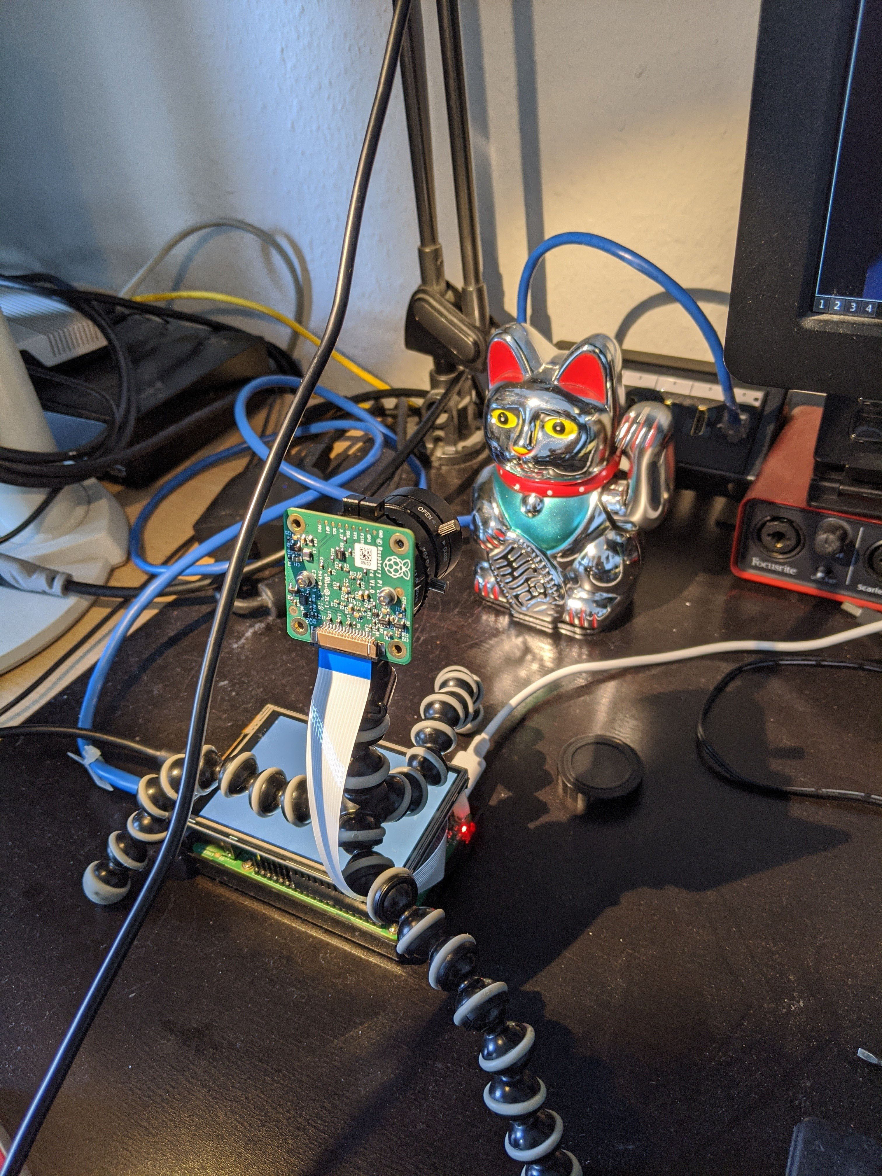
- https://www.raspberrypi.org/documentation/raspbian/applications/camera.md
  - https://github.com/thaytan/gst-rpicamsrc
  - https://github.com/waveform80/picamera
  - https://stamm-wilbrandt.de/en/Raspberry_camera.html
=== gstreamer pipe gen srt mit kaputtem alsasrc-audio vom usb:
gst-launch-1.0 rpicamsrc inline-headers=true annotation-mode=date+time+frame-number+black-background brightness=60 preview=1 awb-mode=1 bitrate=10000000 exposure-mode=fixedfps sensor-mode=1 keyframe-interval=25 ! 'video/x-h264, width=1920, height=1080, framerate=25/1, profile=high' ! muxout. alsasrc device=hw:1,0 actual-latency-time=12000 buffer-time=200000 ! audioconvert ! avenc_aac ! aacparse ! muxout. mpegtsmux name=muxout ! queue ! srtserversink uri='srt://:8888/'`

funktionierendes audio mit ffmpeg und ner pipe in das srt-tool "srt-live-transmit":
ffmpeg -analyzeduration 500000 -probesize 100000 -thread_queue_size 512 -f v4l2 -input_format h264 -video_size 1920x1080 -framerate 30 -i /dev/video0 -thread_queue_size 512 -f alsa -sample_rate 44100 -ac 2 -i hw:1 -map 0:0 -map 1:0 -bufsize 0 -af 'adelay=520|520,volume=0dB' -vcodec copy -acodec aac -f mpegts - | srt-live-transmit -v file://con 'srt://:8888&delay=80' -c 1316
ggf vorher im v4l2 codec parameter setzen:
v4l2-ctl -c video_bitrate=4000000
v4l2-ctl -c h264_i_frame_period=25

rtmp stream from pi cam
raspivid -fps 25 -h 1080 -w 1920 -n -t 0 -g 5 -b 5000000 -stm -o - | gst-launch-1.0 -v fdsrc ! h264parse ! flvmux ! rtmpsink location='rtmp://changeme/stream/bla live=1'

RTP stream sink and source
raspivid -fps 25 -h 1080 -w 1920 -n -t 0 -b 5000000 -o - | gst-launch-1.0 -v fdsrc ! h264parse ! rtph264pay config-interval=1 ! gdppay ! tcpserversink host=10.23.42.145 port=5000
gst-launch-1.0 -v tcpclientsrc host=10.23.42.145 port=5000 ! gdpdepay ! rtph264depay ! decodebin ! autovideosink sync=false

Capture from UVC capture device and stream rtmp

video4linux
gst-launch-1.0 v4l2src device=/dev/video0 do-timestamp=true ! videoscale ! videorate ! videoconvert ! video/x-raw,width=1920,height=1080,framerate=25/1 ! omxh264enc control-rate=variable target-bitrate=5000000 ! h264parse ! flvmux ! rtmpsink location='rtmp://<host>/stream/picam live=1'

raspivid wrapper
gst-launch-1.0 rpicamsrc bitrate=5000000 do-timestamp=true ! h264parse ! flvmux ! rtmpsink location='rtmp://<host>/stream/picam'

read encoded video

read encoded video with ffmpeg from the cam
ffmpeg -f video4linux2 -input_format h264 -video_size 1920x1080 -framerate 30 -i /dev/video0 -vcodec copy -an test.h264

read encoded video with gst and provide output via srt server
gst-launch-1.0 rpicamsrc bitrate=8000000 ! video/x-h264, framerate=25/1, profile=high ! h264parse config-interval=1 ! mpegtsmux ! queue ! srtserversink uri=srt://:10000/

FFMPEG with SRT support on ubuntu 20.04
sudo apt build-dep ffmpeg libsrt-dev
git clone https://github.com/FFmpeg/FFmpeg.git
./configure --prefix=/usr --extra-version=1ubuntu1 --toolchain=hardened --libdir=/usr/lib/x86_64-linux-gnu --incdir=/usr/include/x86_64-linux-gnu --arch=amd64 --enable-gpl --disable-stripping --enable-avresample --disable-filter=resample --enable-gnutls --enable-ladspa --enable-libaom --enable-libass --enable-libbluray --enable-libbs2b --enable-libcaca --enable-libcdio --enable-libcodec2 --enable-libflite --enable-libfontconfig --enable-libfreetype --enable-libfribidi --enable-libgme --enable-libgsm --enable-libjack --enable-libmp3lame --enable-libmysofa --enable-libopenjpeg --enable-libopenmpt --enable-libopus --enable-libpulse --enable-librsvg --enable-librubberband --enable-libshine --enable-libsnappy --enable-libsoxr --enable-libspeex --enable-libssh --enable-libtheora --enable-libtwolame --enable-libvidstab --enable-libvorbis --enable-libvpx --enable-libwavpack --enable-libwebp --enable-libx265 --enable-libxml2 --enable-libxvid --enable-libzmq --enable-libzvbi --enable-lv2 --enable-omx --enable-openal --enable-opencl --enable-opengl --enable-sdl2 --enable-libdc1394 --enable-libdrm --enable-libiec61883 --enable-nvenc --enable-chromaprint --enable-frei0r --enable-libx264 --enable-shared --enable-libsrt --disable-avio

