Minions
The “Minions” are Intel NUC Core i7 machines we use for master release encoding on site at the events. In general we try to use small from factor PCs with high single core performance, as of now in two generations:

Minion 2-4: Gigabyte BRIX Pro
At the moment we got four three of these little boxes.
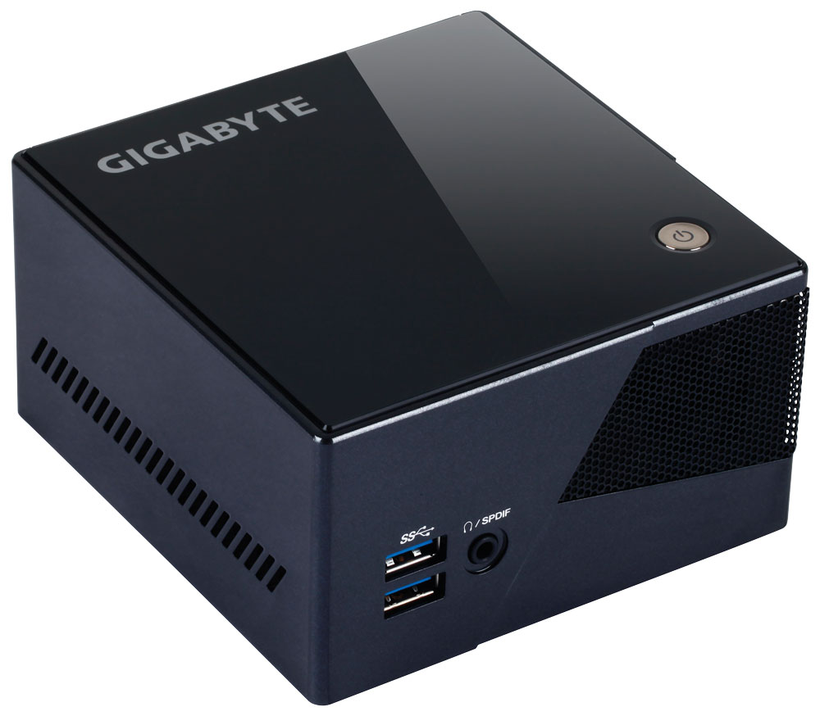
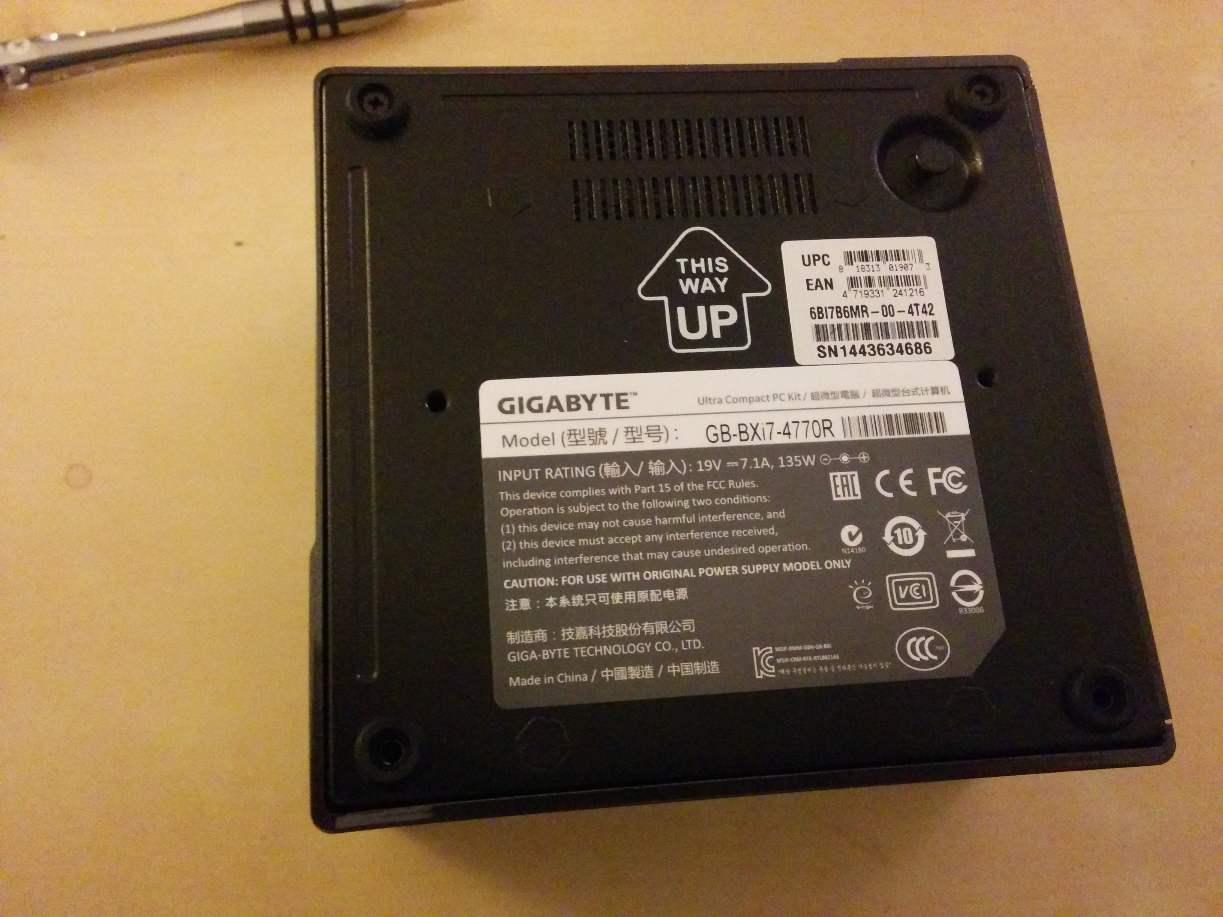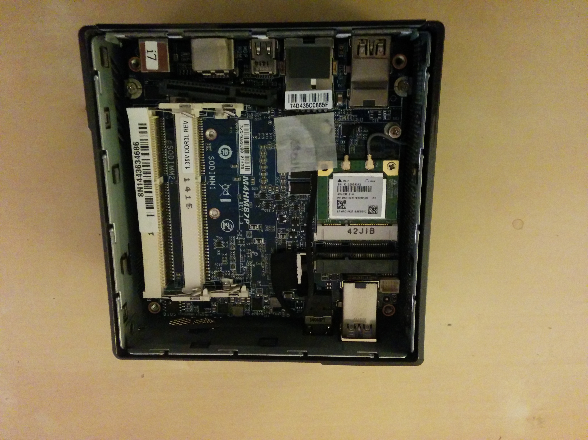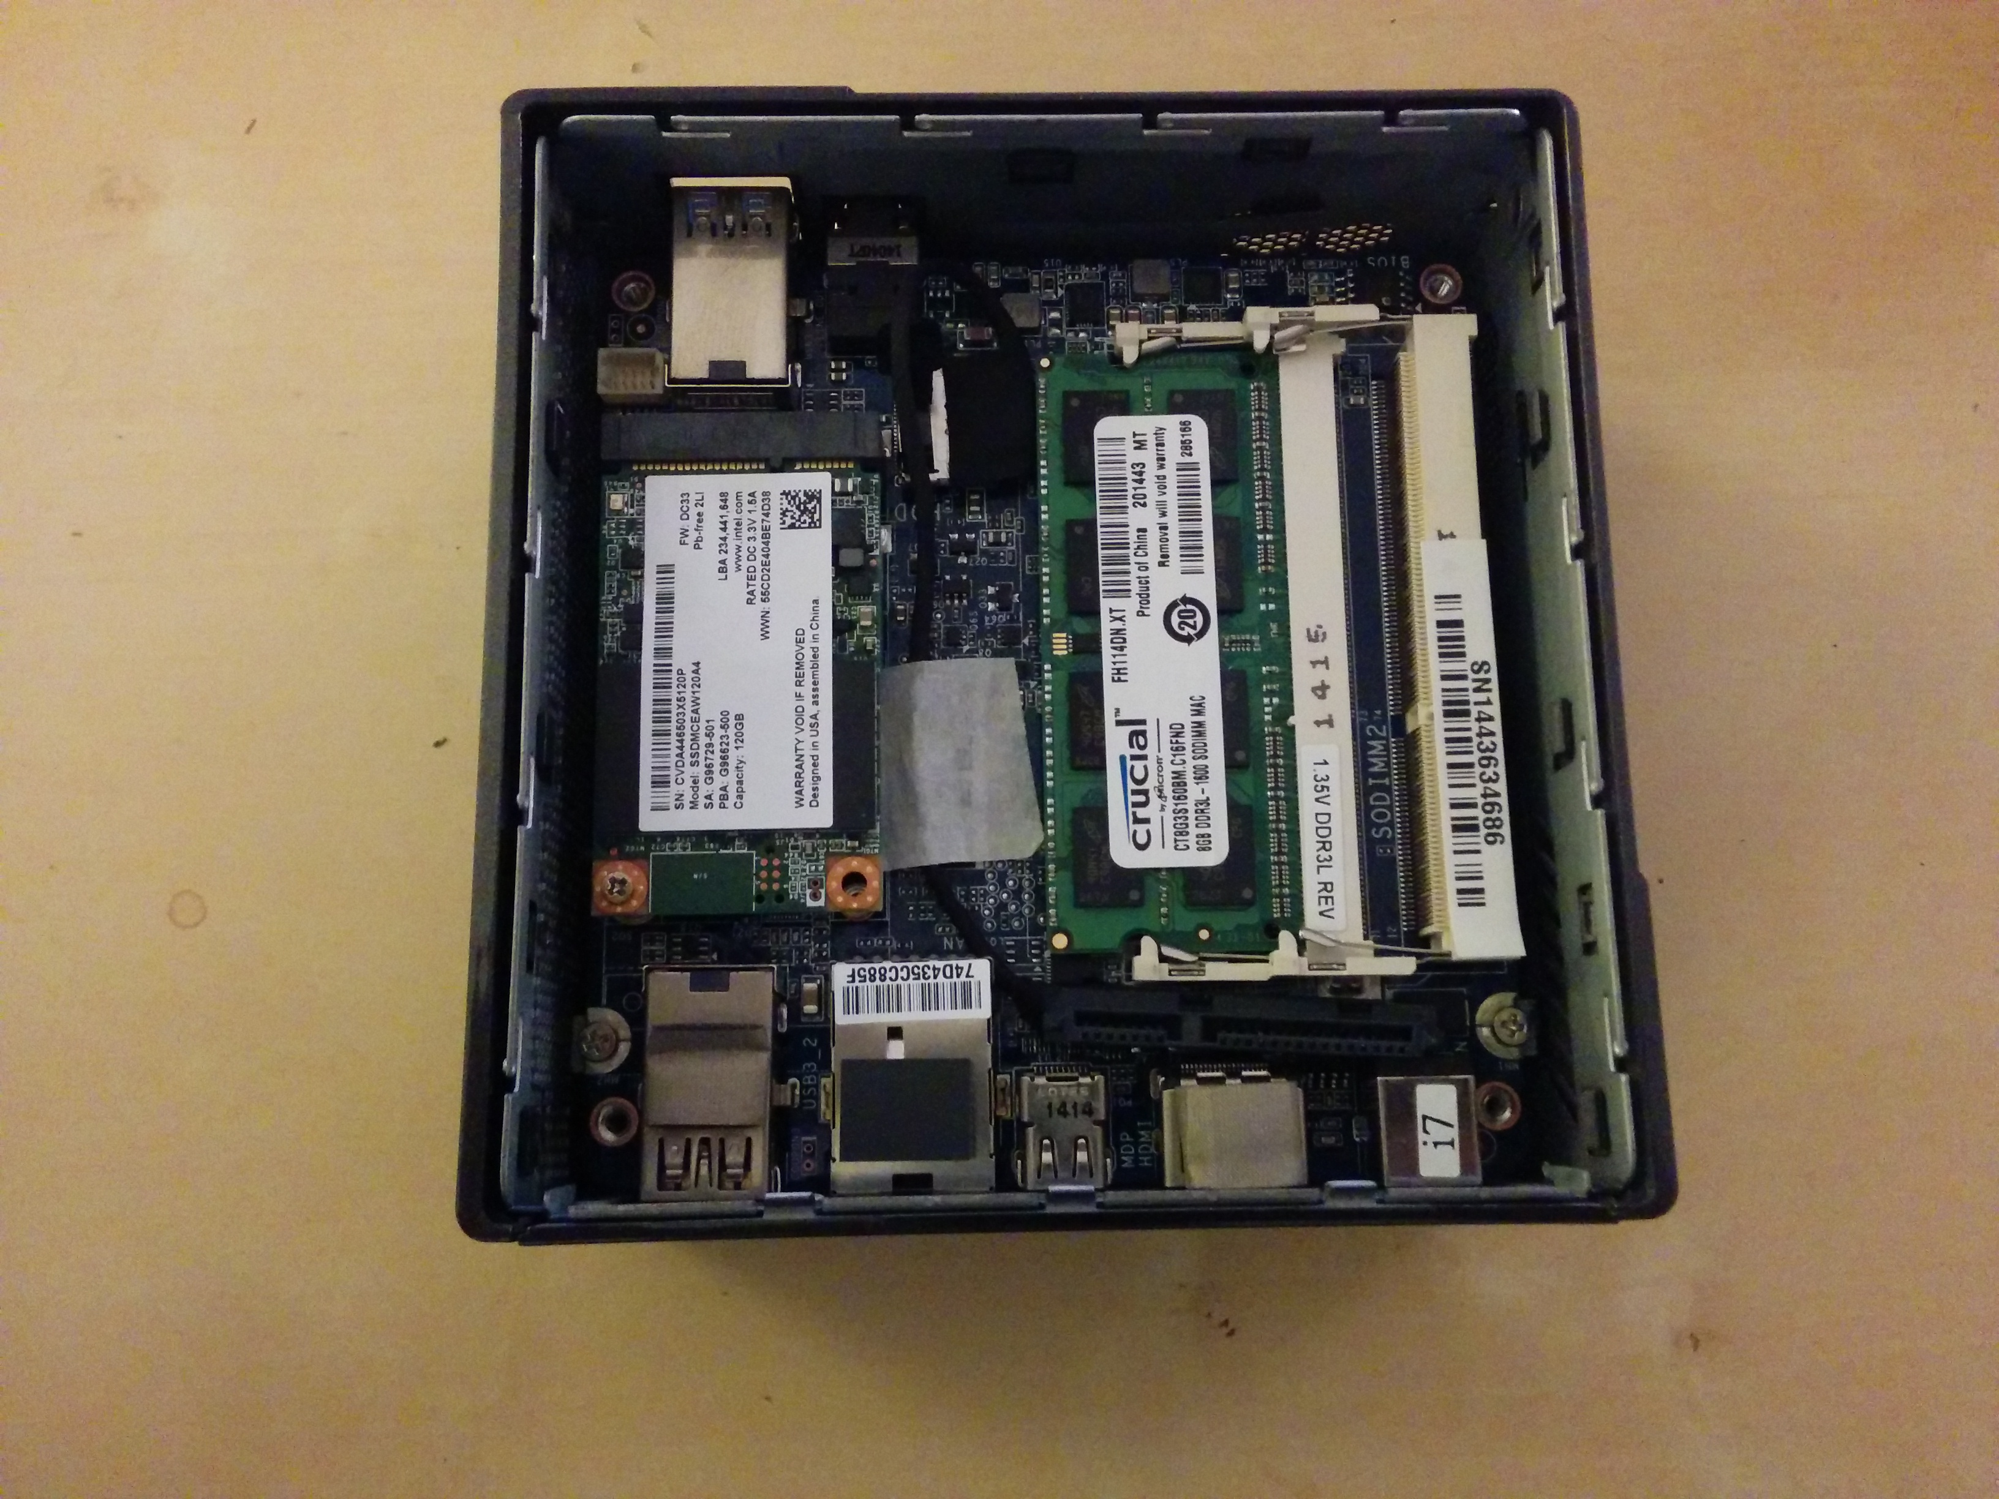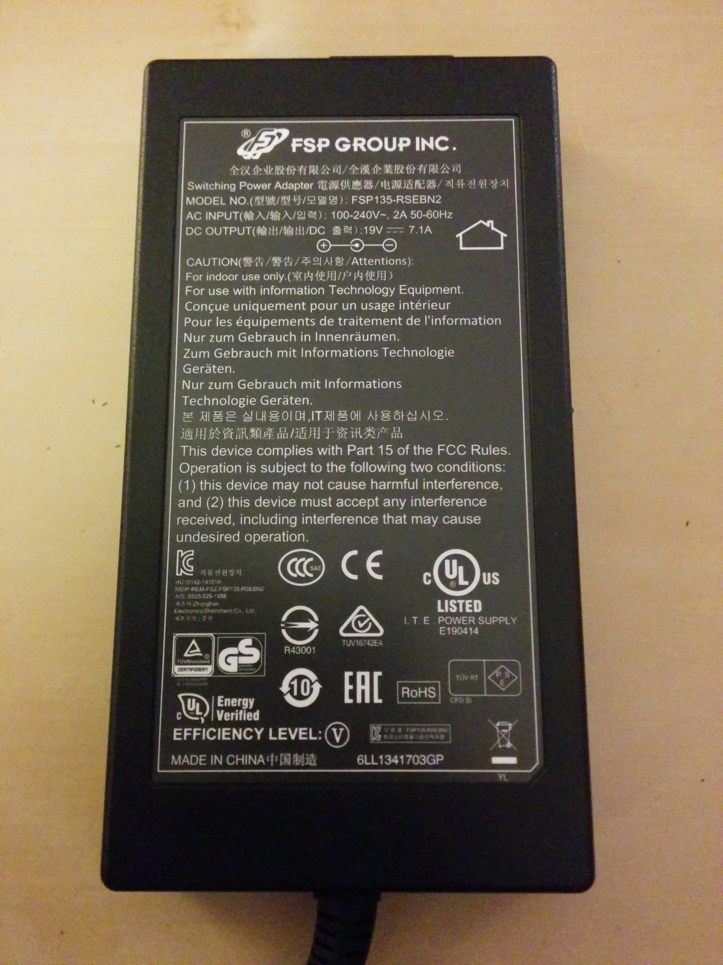
more pictures
manual
Gigabyte BRIX Pro GB-BXi7-4770R (rev. 1.0)
- Core i7 4770R / 3,2 GHz
- Intel® Iris™ Pro graphics 5200
- 2 TB 2,5 Sata HDD ST2000LM003 (only minion 3+4 at the moment)
- Ultra compact PC design - 0.79L (62 x 111.4 x 114.4 mm)
- 120 GB Samsung 850 EVO MZ-75E120 mSata SSD
- Corsair Value Select 8GB PC4-17000 - 8 GB - DDR4 - 2133 MHz (CMV8GX4M1A2133C15)
- IEEE 802.11 a/b/g/n/ac Wi-Fi / Bluetooth 4.0 Mini-PCIe card
- HDMI plus Mini DisplayPort Outputs (supports dual displays) [dual display (Mini DisplayPort) is supported by Gigabyte only for Windows!]
- 4K resolution output (4096 x 2304 via HDMI)
- 4 x USB 3.0
- Gigabit LAN
- Headphone jack with S/PDIF
- VESA mounting bracket (75 x 75mm + 100 x 100mm)

Minion 1, 5, 6: Modula/Intel NUC
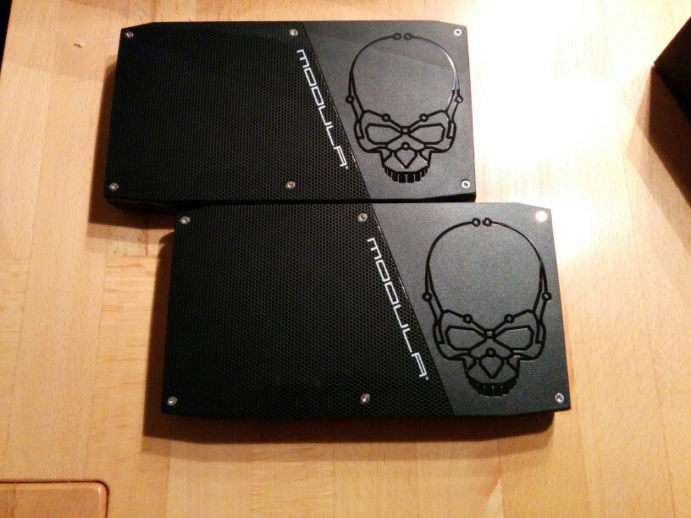
Intel Skull Canyon Mini-PC B01MXKHHEK
- Intel Core i7-6770HQ,
- 8GB DDR4,
- 256GB PCIe M.2 SSD,
- Intel Iris Pro Grafik
- https://www.intel.com/content/dam/support/us/en/documents/boardsandkits/NUC6i7KYK_TechProdSpec.pdf

