USA Server - usa.lan.c3voc.de

Hardware
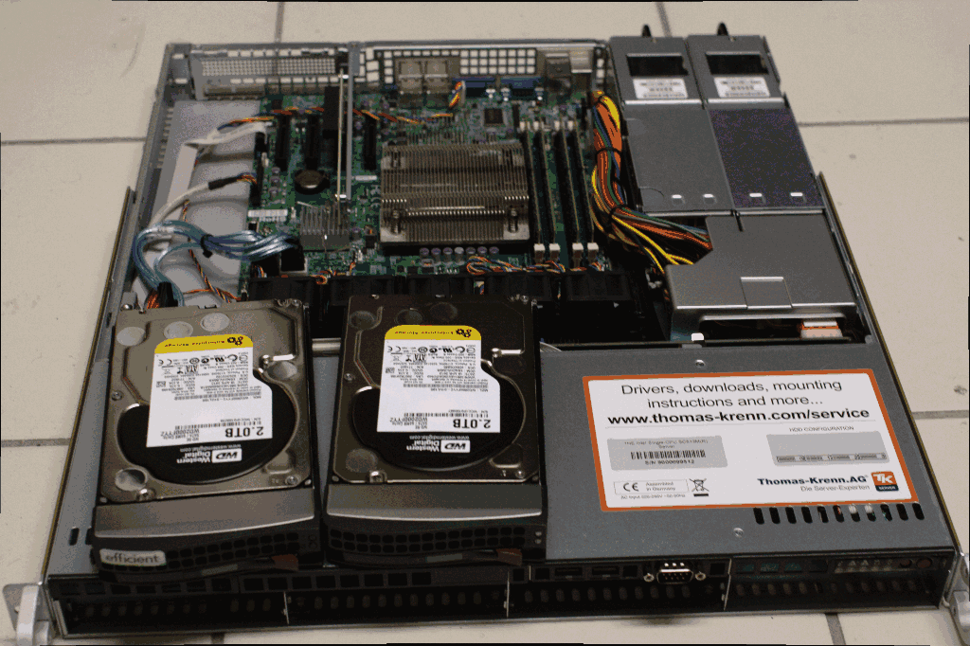
Thomas Krenn - 1HE Intel Single-CPU SC813M(R) Server
- Chassis: SC813MTQ-R400CB
- Intel Xeon 4-Core E3-1265L V2 @ 2.50GHz
- Supermicro Mainboard X9SCM-F
- 32 GB ECC DDR3 1600 RAM 2 Rank ATP (4x 8192 MB)
- 2x 2000 GB SATA III WD Raid Edition 3,5“ 7.2k - WD2000FYYZ
- 2x 6Gbit/s + 4x 3Gbit/s SATA-Ports - kein HW Raid
- 2x 1Gbit Intel NICs
- KVM over LAN, IPMI 2.0
- 2x 400 Watt energiesparendes, redundantes Netzteil
- 10GE NIC (2x XFP!!1!) - Chelsio S320E-LP-CR

