= Storage 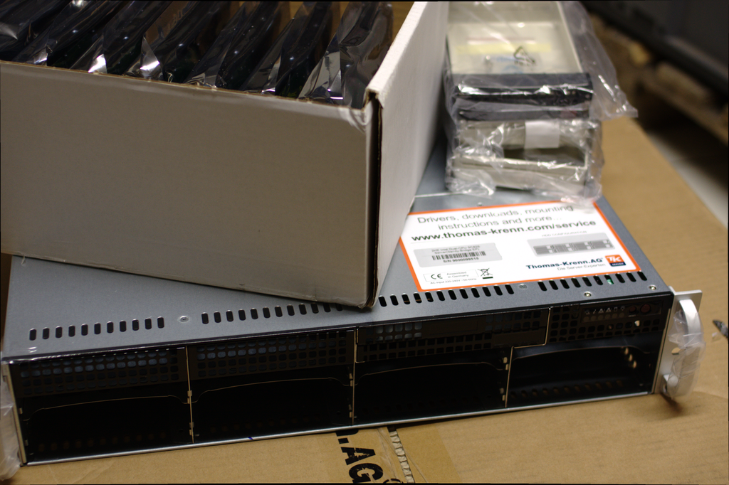 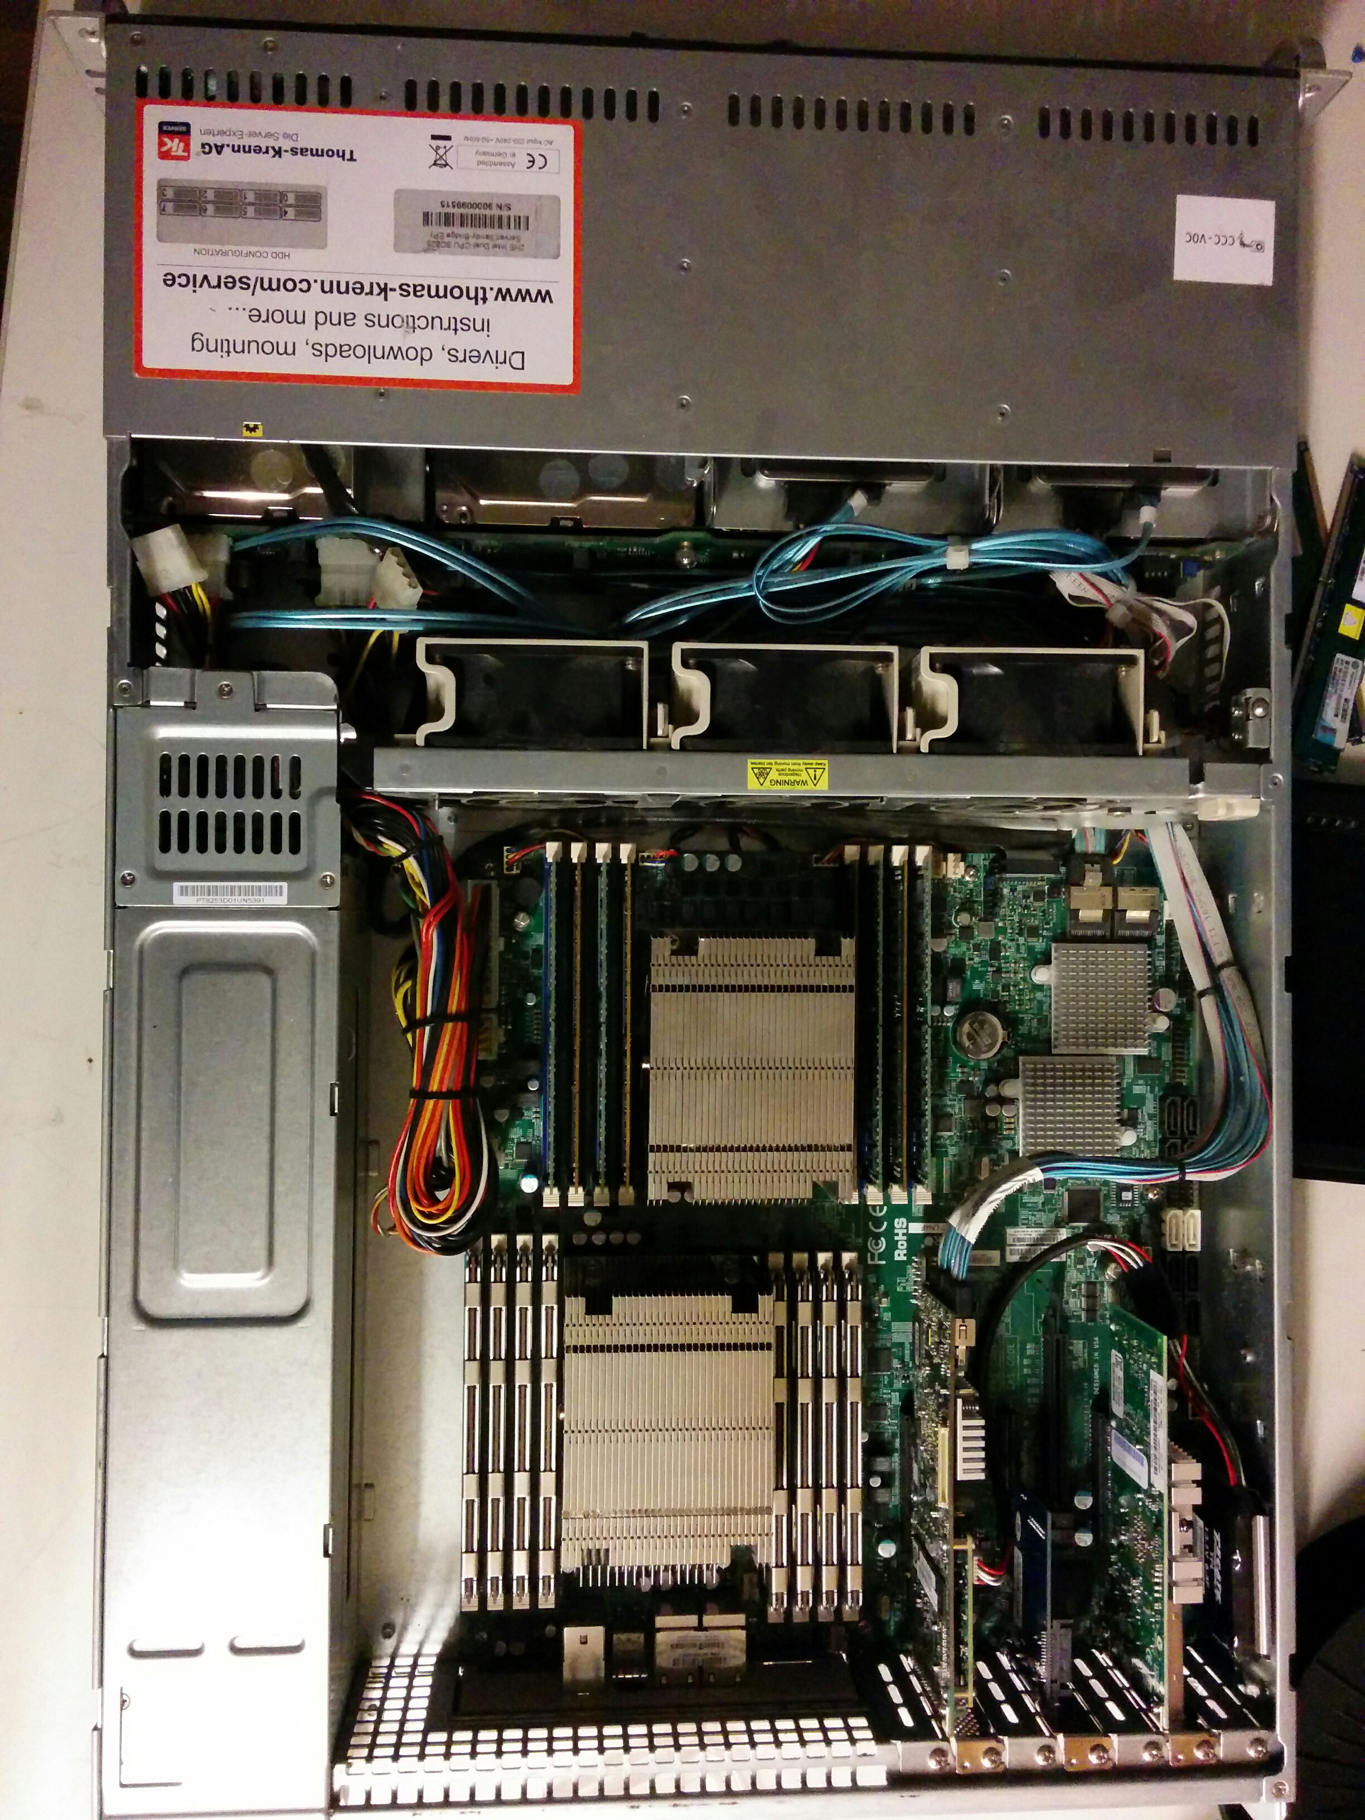 == Hardware
Thomas Krenn Intel Dual-CPU SC826 Server
- 2HE, 19“, 89 mm (H), 437 mm (B), 648 mm (T) SC825TQ-R740LPB
- Supermicro X9DR7-LN4F
- 128 GB ECC Registered DDR3 ATP (16x 8192 MB 1066MHz)
- 2x Intel Xeon E5-2637 v2, 4x 3.5 GHz
- 2x 240GB Intel SSD MLC 520
- 7x 3000 GB SATA III WD Raid Edition 3.5“ 7.2k (WD3000FYYZ) → 13 TB nutzbarer Storage mit HW-RAID6 + Hot-Spare
- LSI 9271-8i SAS2 8x intern mit BBU
- Intel I350 Quad Ethernet Controller
- Intel X520-DA2 (82599EB) Dual-Port 10 Gigabit Ethernet SFP+
== Software
- Debian Stable (wheezy)
- megacli LSI RAID-Management tweaks
- RAID-Controller Konfiguration 14.01.2014

