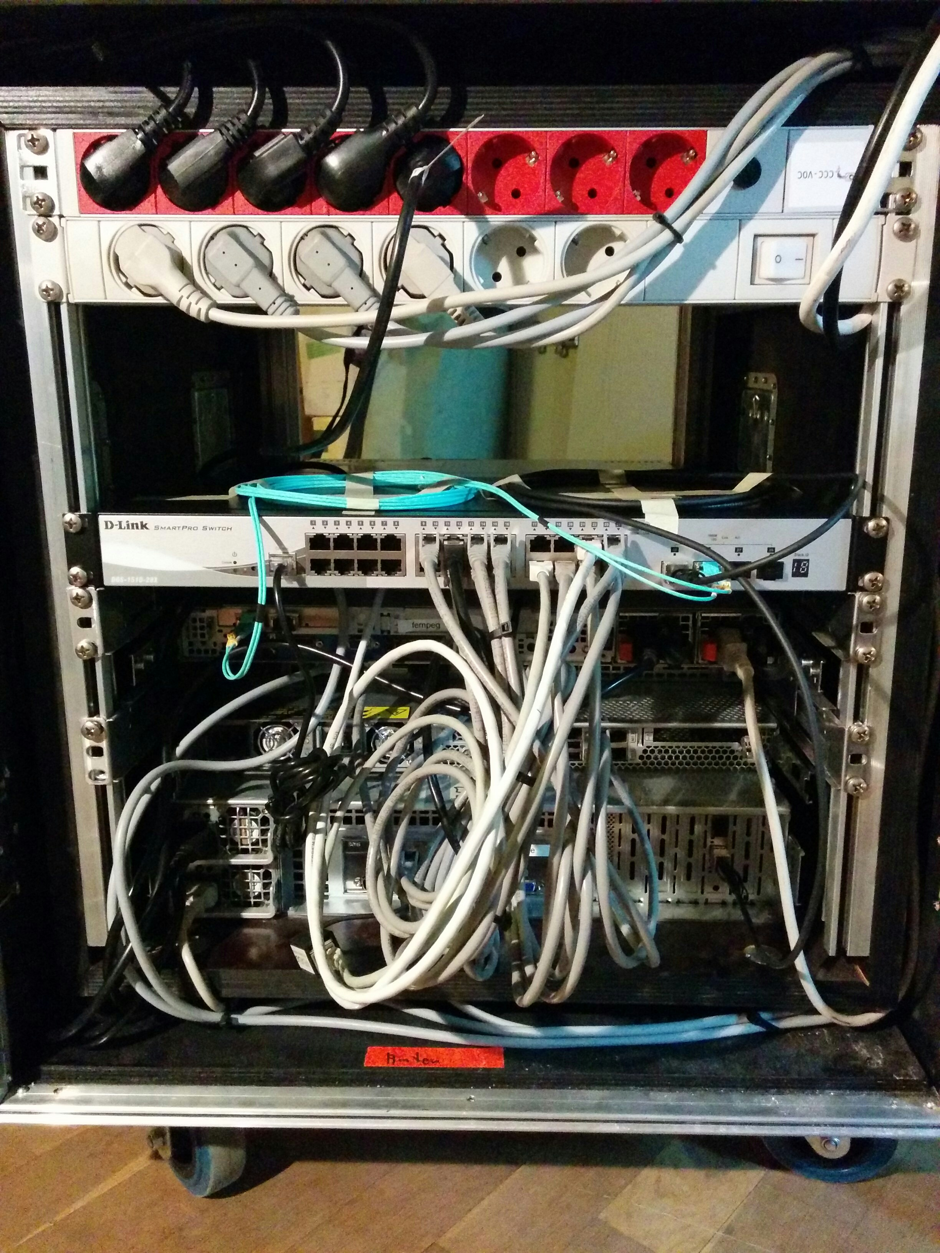
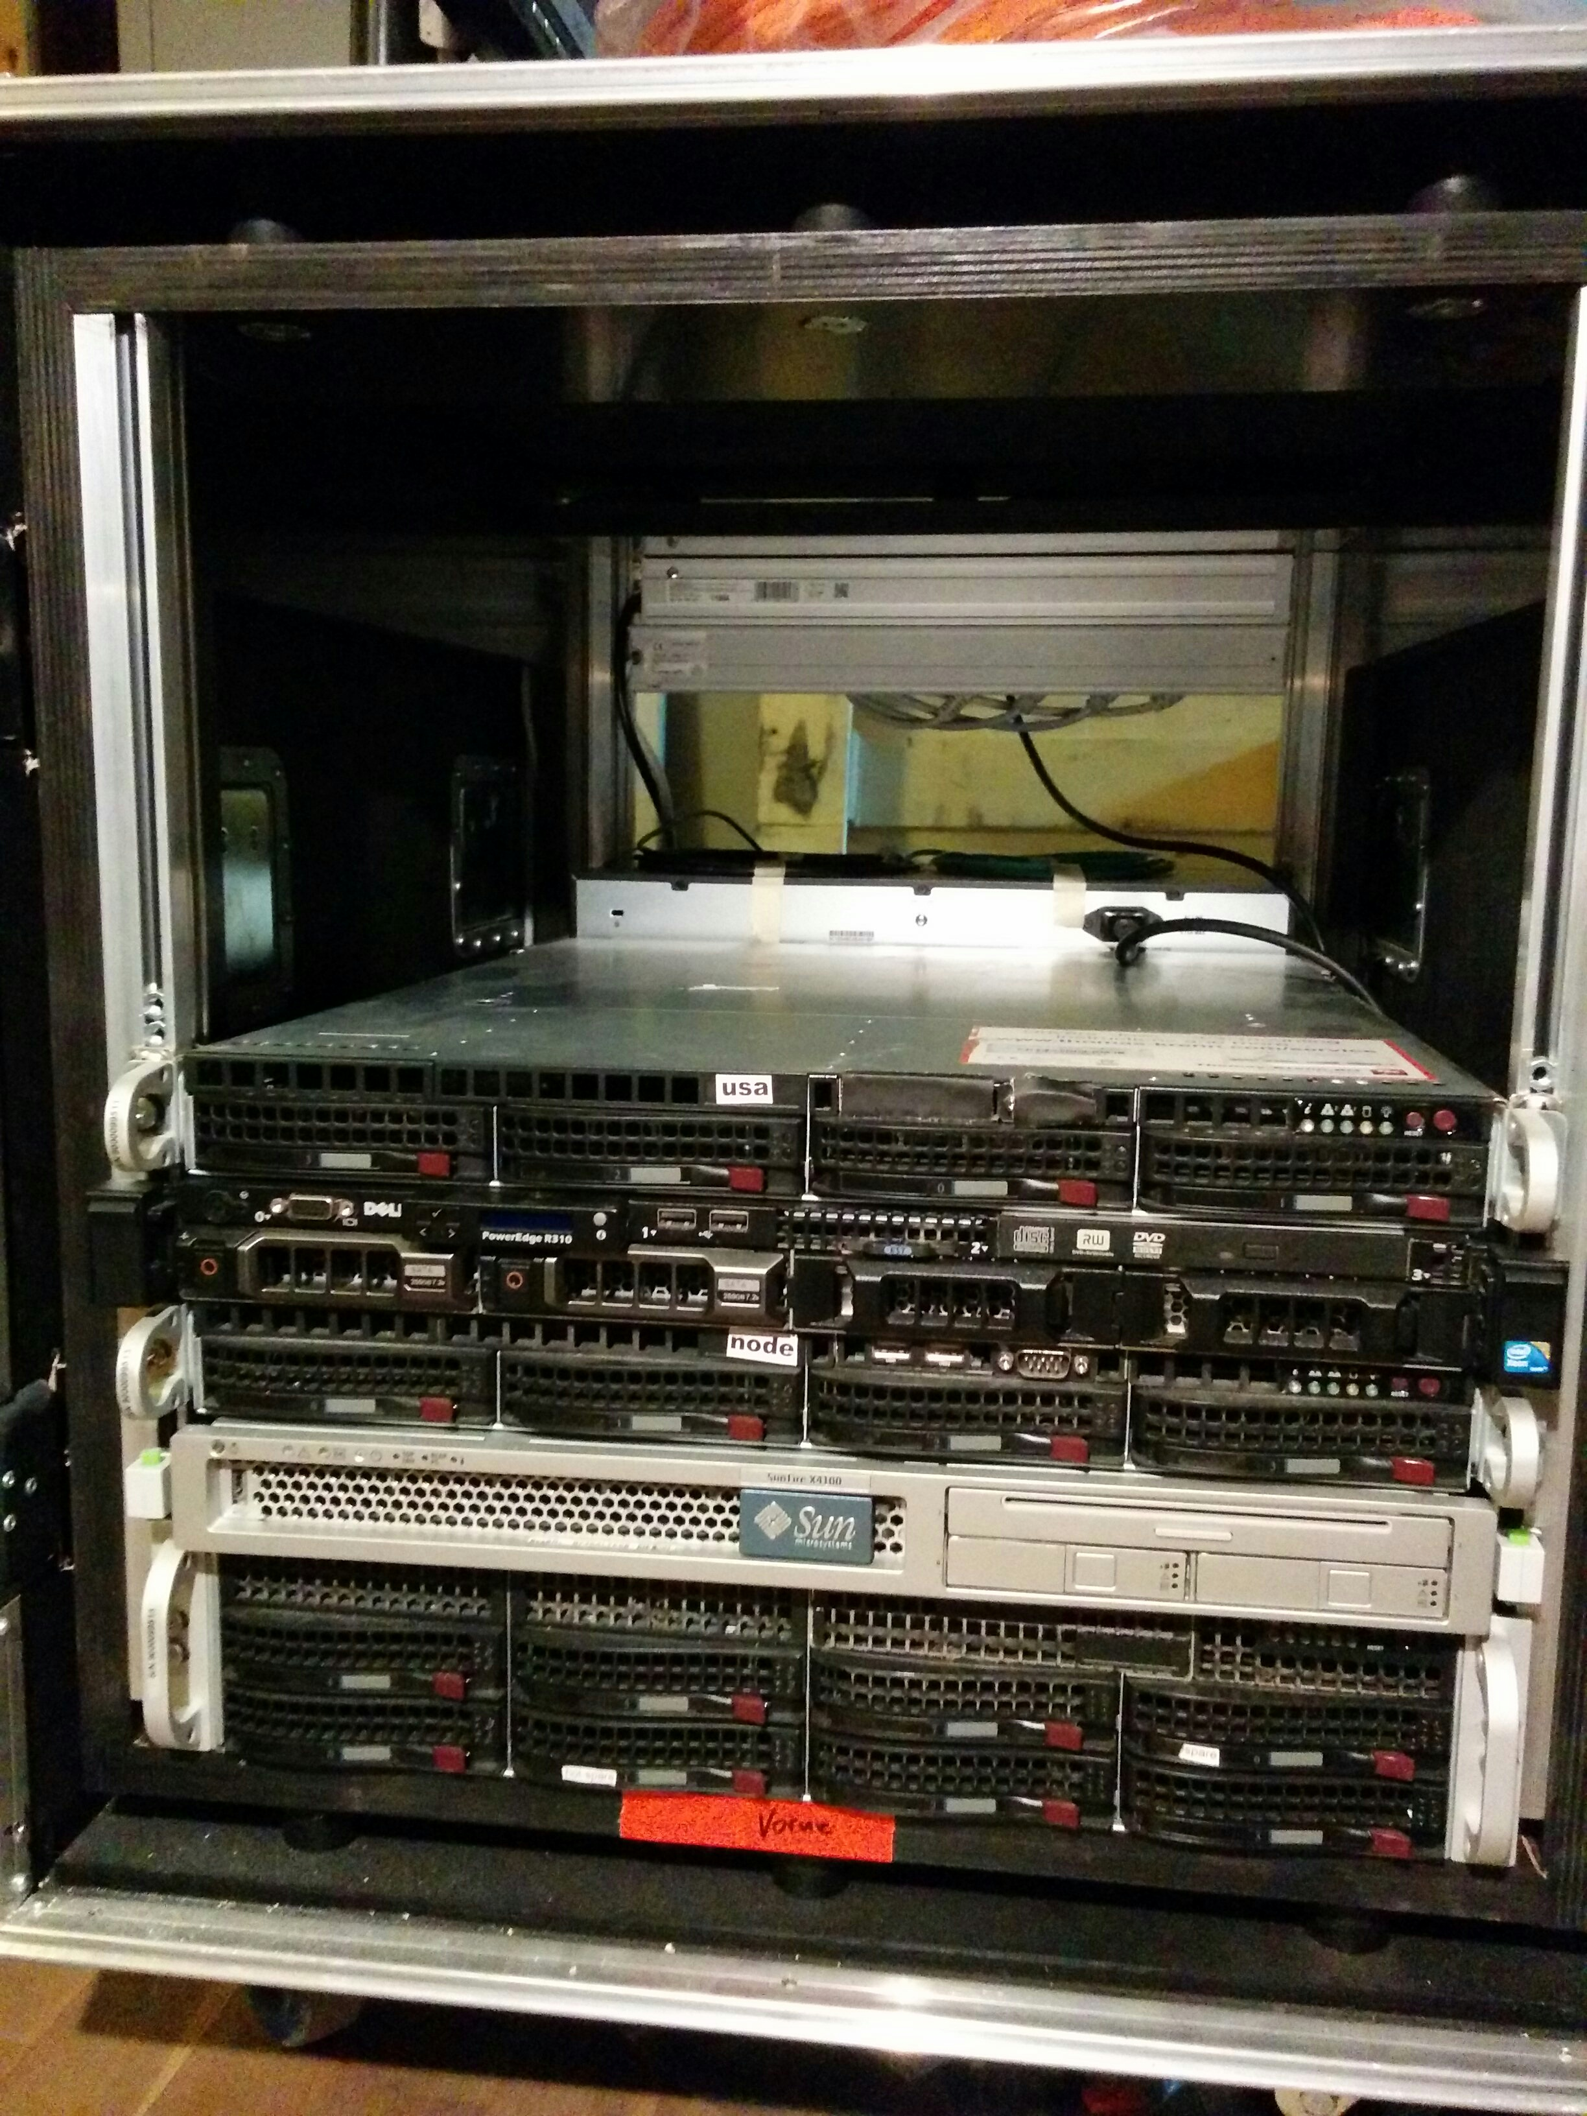

Event Server
- node - local VM host
- storage - local storage server
- usa - local stream relay
- fempeg
- deskjet - local file mirror

