= Encoder PCs
The Encoder Cubes are handling the video capturing, switching and recording and are the source for the live streams.
We run debian together with Voctomix on them. The name encoderX might be misleading and was more fitting in the past – we are currently migrating their naming scheme to cubeX. Today the cubes only run voctomix core and encode live streams as the release encoding was delegated the minions. However, the cubes might be used to encode release files during longer breaks e.g. in the night time.
== Encoder cube 1-4 Our first generation cubes.
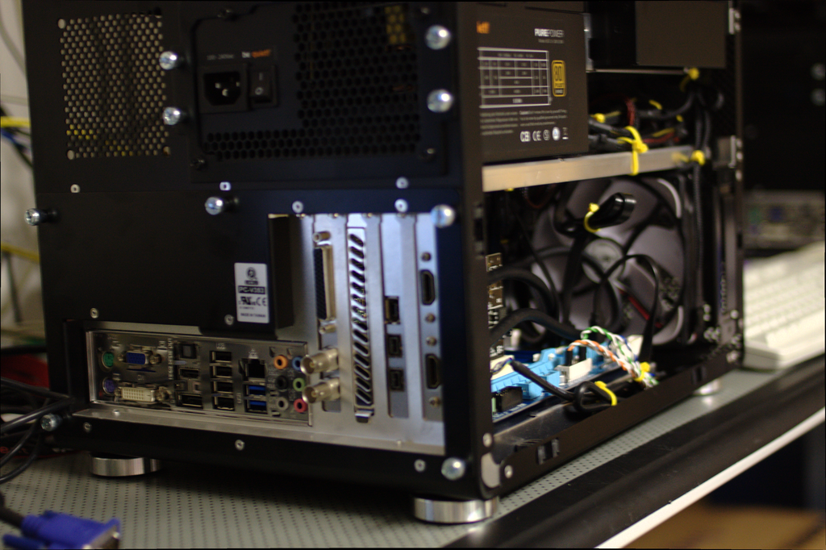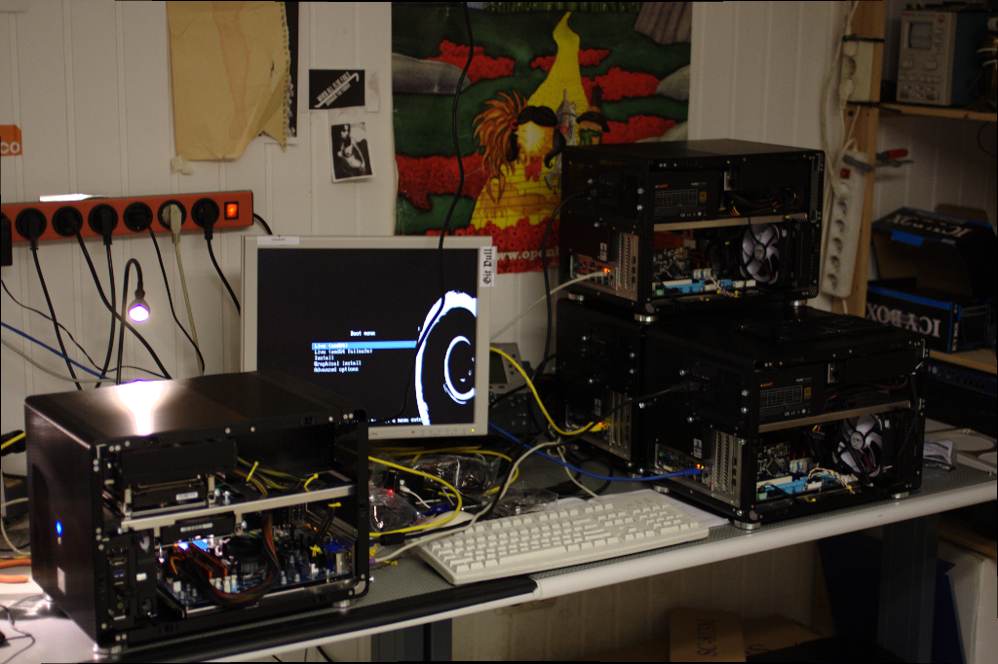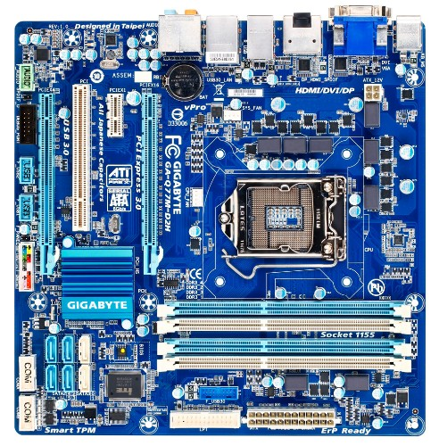
- Lian Li PC-V353
  - μATX
- Gigabyte GA-Q77M-D2H BIOS
  - vPro
  - Q77 Chipset
  - Gbit LAN (Intel 82579), USB 3.0, PCIe 3.0, 2x PCI-E x16 (4x)
- be quiet! Pure Power L8-CM 530W - 80+
- Intel Core i7 3770 - 3,1 GHz - 4 Kerne BX80637I73770S
  - 4x 3.40GHz
  - 77W TDP
- 2x 4 GB - Kingston HyperX PC3-12800U CL9-9-9-27
- 2x 3 TB – Western Digital WD30EFRX (partially replaced with other models)
- 2x SDI Card Black Magic DeckLink Mini Recorder
  - 1x SDI/HDMI in
- Firewire PCI Card
== Encoder cube 5 Our second generation cube: We needed to switch the case, got some more memory by accident and lately updated to a DeckLink Duo in favor of one of the DeckLink Mini Recorder
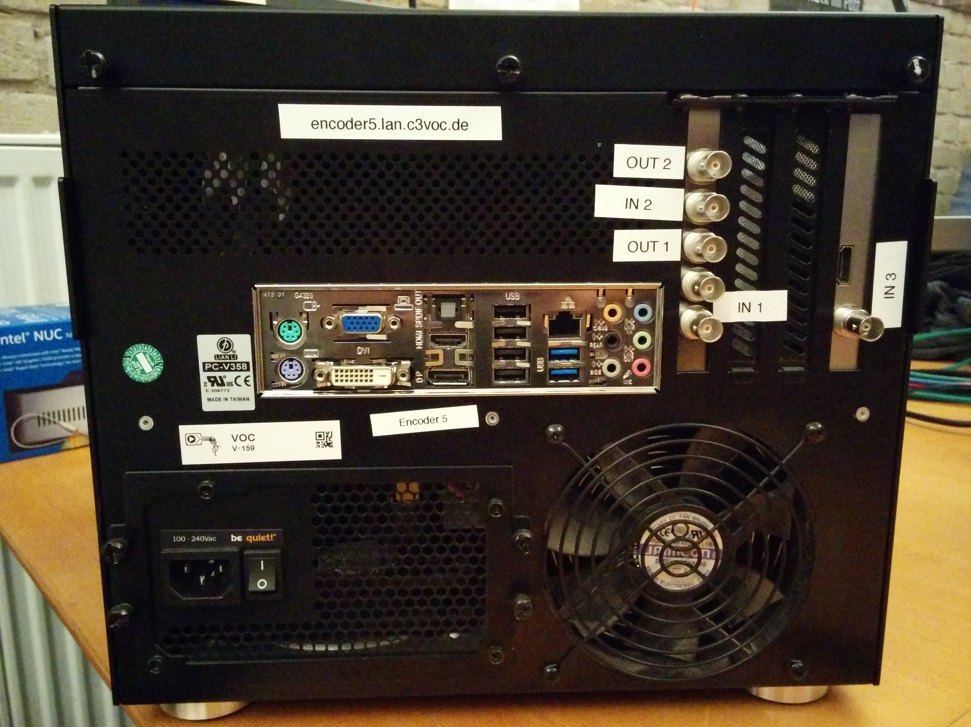
- Gigabyte GA-Q77M-D2H BIOS
- Intel Core i7 3770 - 3,1 GHz - 4 Kerne BX80637I73770S
- G.Skill ARES - Memory - 16GB : 4 x 4GB F3-1600C9D-8GAO
- Seagate Enterprise Capacity CS 3TB ST3000NC002
- WD SE WD3000F9YZ - Festplatte - 3TB
- Be quiet! Pure Power BQT L8-530W - Stromversorgung (intern) -
  - ATX12V 2,3 - 530 Watt - aktive PFC (BN181)
- Lian Li PC-V358B - Mini Tower - Mikro-ATX
- 2x Noiseblocker NB eLoop Bionic B12-1 120x120x25
- 1x SDI Card Black Magic DeckLink Mini Recorder
  - 1x SDI/HDMI in
- 1x SDI Card Black Magic DeckLink Duo
  - 2x SDI In/Out
  - 1x CLK
== Encoder cube 6 Our third generation cube: It was time to say good by to the Ivy Bridge and hello to Sky Lake. This also required a new mainboard.
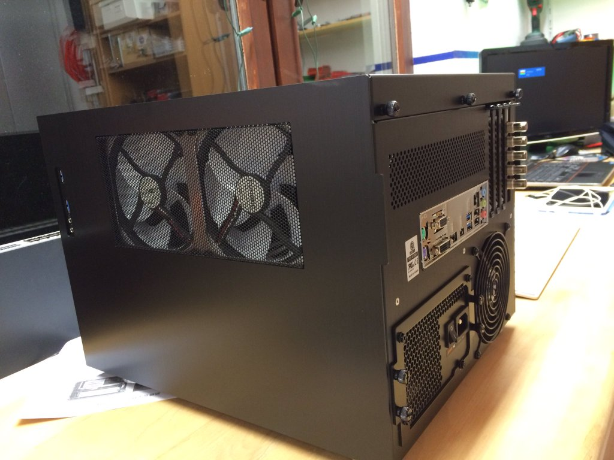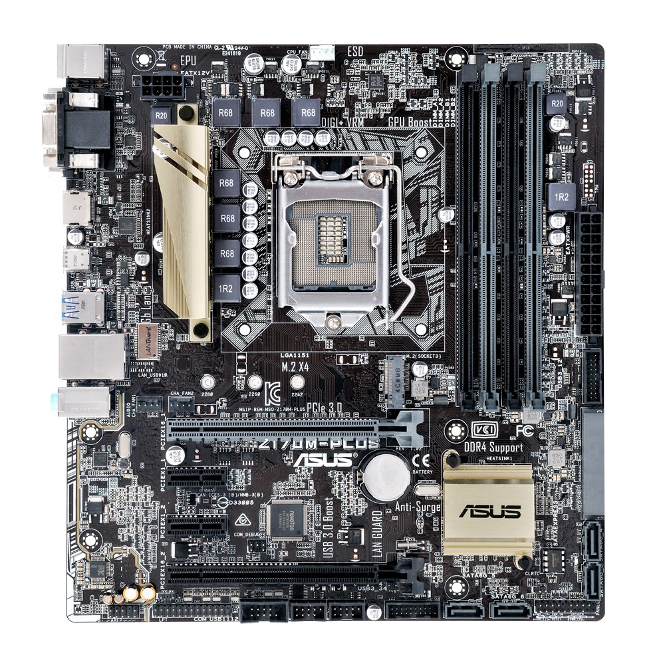
- CPU Intel Core i7-6700K BOX 4,10GHz 8M Cache FC-LGA14C (Achtung: Boxed-Version der *K Reihe enthäkt keinen Kühler/Lüfter)
  - Alpenföhn Silvretta CPU-Kühler
- 2x HDDs
  - Western Digital Red Pro 3TB 7200RPM SATA 6Gbps 64MB Cache 3TB WDC (WD3001FFSX-68JNUN0)
  - Seagate Enterprise Capacity 3.5 HDD ST3000NM0033 3TB - SATA-600 - 7200 U/min - Puffer: 128M (ST3000NM0033-9ZM178)
  - Hauptsache 7200RPM SATA-600
- Crucial - DDR4 SDRAM - 16GB : 2 x 8GB - DIMM 288-PIN - 2133 MHz / PC4-17000 - CL15
- ASUS Z170M-PLUS - Motherboard - Mikro-ATX - LGA1151 Socket
- Lian Li PC-V358B - Mini Tower - Mikro-ATX
  - 2x Noiseblocker NB eLoop Bionic B12-1 120x120x25
  - Case kommt mit 2 Lüftern, die man ggf. auch gegen die Noiseblocker ersetzen will
- Be quiet! Pure Power BQT L8-530W - BN181
- 1x SDI Card Black Magic DeckLink Mini Recorder
  - 1x SDI/HDMI in
- 1x SDI Card Black Magic DeckLink Duo
  - 2x SDI In/Out
  - 1x CLK In
https://c3voc.de/gallery/misc/encoder6/
== Minions see Minions https://c3voc.de/gallery/misc/minion/
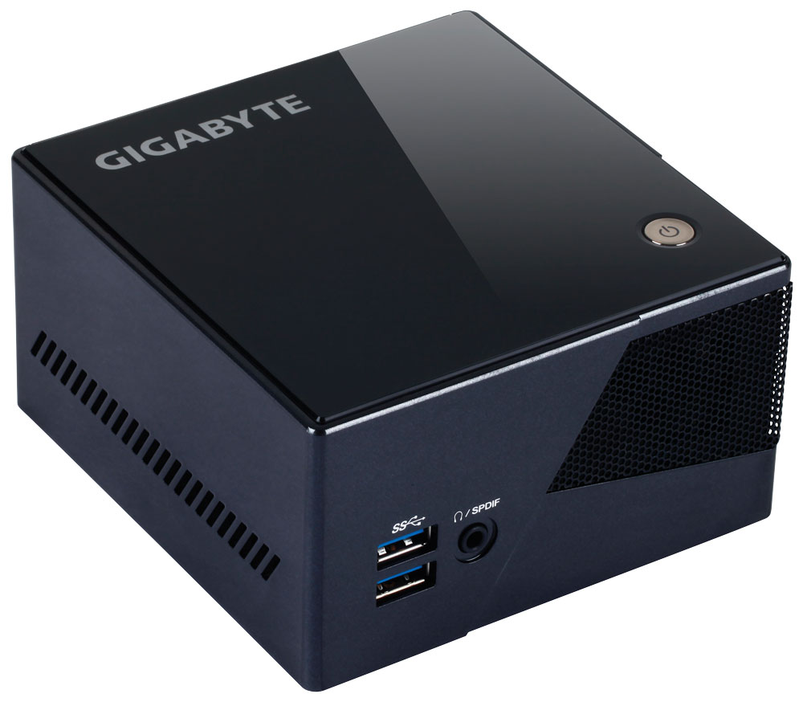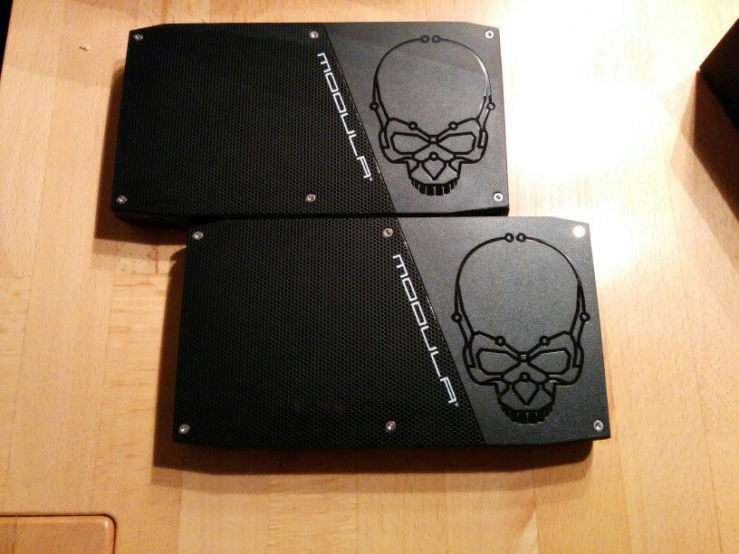
= Dezentralized encoders
== RZ Berlin
Speedy & Tweedy, see Reencoder, 1HE chassis
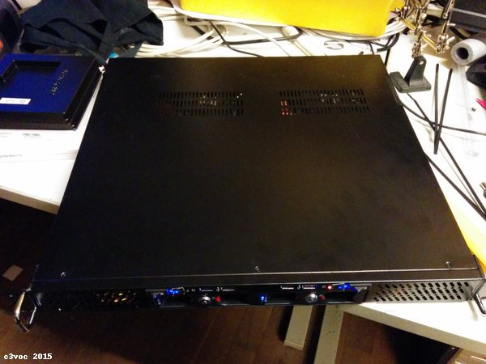 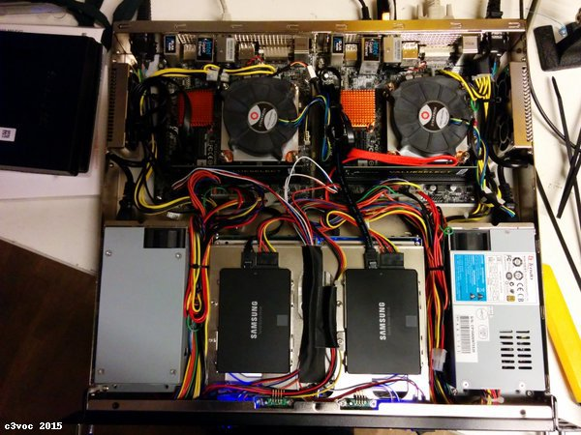 == Munich (Encoder M)
Initially based on first generation encoder cube, but in 3HE chassis with 4HE rackbag to be more portable. The CPU generation is between Encoder 5 and 6 → 2.5 generation cube.
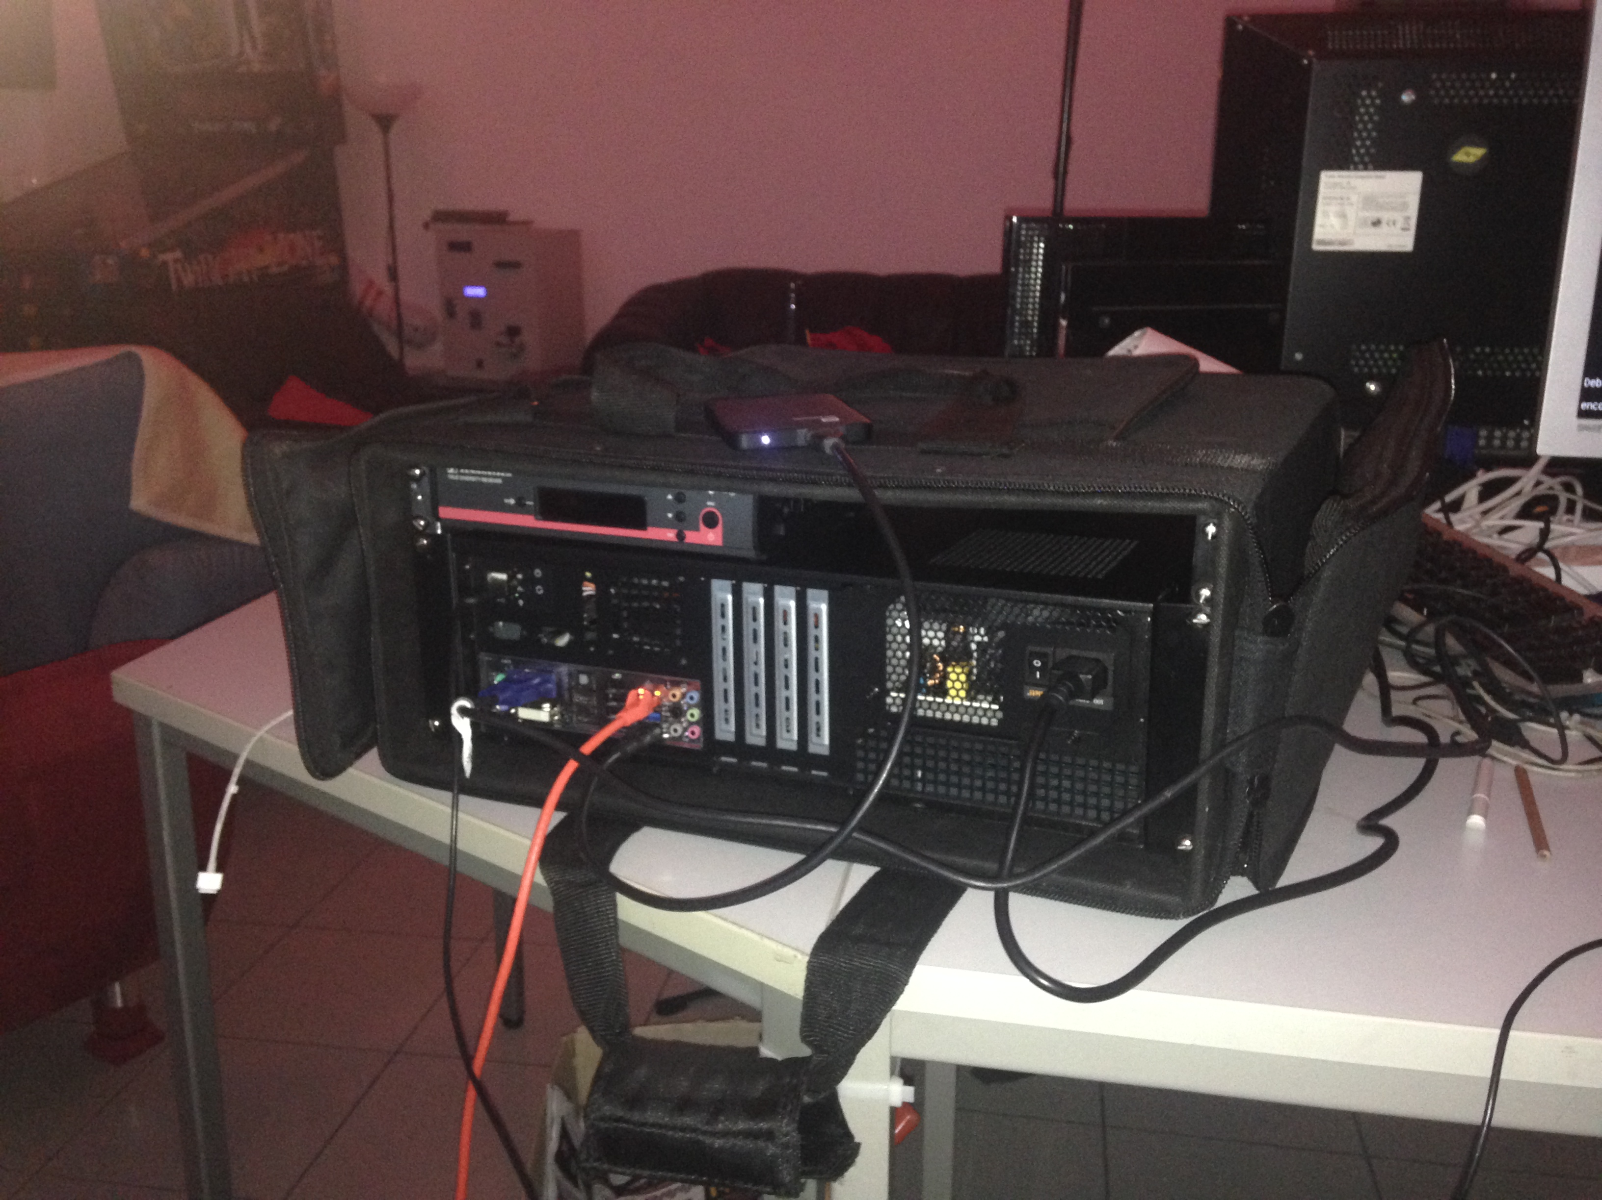
(note DeckLink pci card missing → TODO update picture to current state)
https://c3voc.de/gallery/misc/encoder-m/
- Motherboard - Gigabyte GA-Q87M-D2H - 1,0 - Mikro-ATX - LGA1150 Socket - Q87 - USB3.0 - Gigabit LAN
- CPU Intel Core i7-4770K 3.50GHz LGA1150 BOX (BX80646I74770K)
- RAM 16GB : 2 x 8GB - DIMM 240-PIN - DDR3 - 1333 MHz / PC3-10666 - CL9 (F3-1333C9D-16GAO)
- 1x HDMI/SDI Card Black Magic DeckLink Studio 4K
  - 1x SDI/HDMI in
  - 1x SDI/HDMI out
- HDDs (2)
  - Seagate Enterprise Capacity CS ST3000NC002 - Festplatte - 3TB - intern - 8,9 cm (3,5“) - SATA-600 - 7200 U/min - Puffer: 64MB (ST3000NC002)
  - WD SE WD3000F9YZ - Festplatte - 3TB - intern - 8,9 cm (3,5“) - SATA-600 - 7200 U/min - Puffer: 64MB (WD3000F9YZ)
- Be quiet! Pure Power BQT L8-530W
- Noiseblocker NB eLoop Bionic B12-PS 400-1500 120×25 (ITR-B12-PS)
- 19 Zoll 3HE Servergehäuse IPC C330
== Cologne (C4)
https://doku.ccc.de/Chaos_Computer_Club_Cologne/PA_Encoder_Cube_2016
- Prozessor Intel Core i7 6700K
- Mainboard Asus Z170M-Plus
- RAM 16GB Crucial CT2K8G4DFD8213 DDR4-2133 DIMM CL15 Dual Kit
- Prozessor-Lüfter EKL Alpenföhn Silvretta
- Netzteil be quiet! Pure Power L8 CM 530W
- Festplatten
  - Western Digtial Red Pro WD3001FFSX 3TB
  - Seagate Enterprise Capacity ST3000NM0033 3TB
- Gehäuse Lian Li V351B/V355B/V358B
- 2x Blackmagic Design DeckLink Mini Recorder
== Nuermberg (osc1 + osc2)
- ASUS PRIME Z270M-PLUS, Intel Z270 Mainboard - Sockel 1151
- Intel Core i7-7700K 4,2 GHz (Kaby Lake) Sockel 1151 - tray
- BitFenix Colossus M Mini-ITX Gehäuse RED/BLUE/GREEN LED - schwarz
- 2x Seagate BarraCuda HDD, SATA 6G, 7200RPM, 3,5 Zoll - 3 TB
- LG GH24NSD1 5,25 Zoll SATA DVD-Brenner, bulk - schwarz HyperX Fury Series, DDR4-2666, CL15 - 32 GB Kit
- be quiet! Straight Power 10 CM Netzteil, 80 Plus Gold, modular - 600 Watt
- be quiet! Shadow Rock LP Low Profile CPU-Kühler - 120mm
- 2x Blackmagic Design DeckLink Mini Recorder

