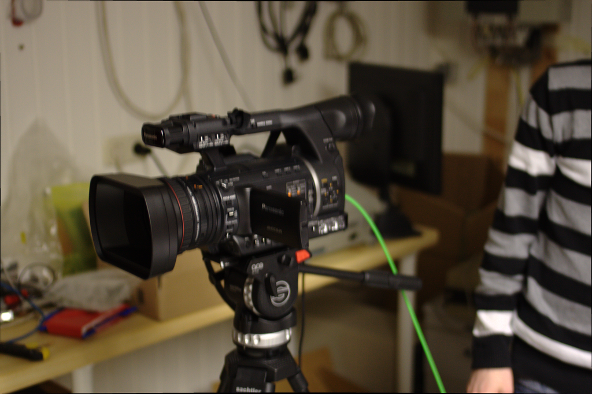

Cameras and tripods

Cameras
Our main camera model for all 6 Lecture Room Set 2.0 is the Sony PXW-Z200. Our previous generation included the Panasonic AG-AC 160 AEJ. There exist also at least two JVC GY-HM200E for alternate use-cases.
- 6x Sony PXW-Z200 (part of Lecture Room Set 2.0)
- 6x Panasonic AG-AC 160 AEJ (first generation VOC cases)
- 2x + X JVC GY-HM200E
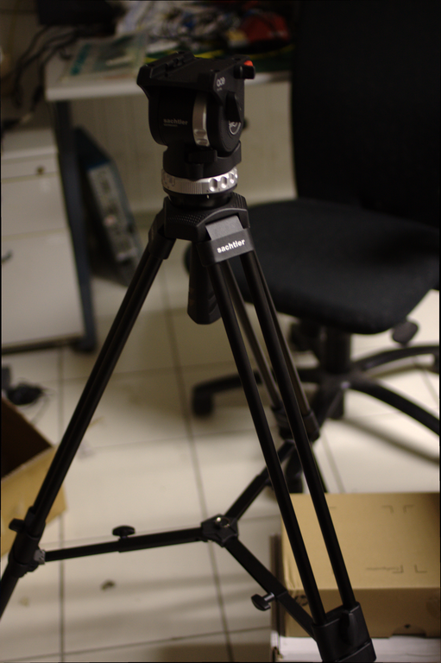

Tripods
- 4x Sachtler System ACE M MS manual_system_ace_m_ms.pdf
- 2x Sachtler System ACE M GS
Compatible replacement quick release plates:
- 501PL

