sigint13
Freitag, den 5. Juli, bis zum Sonntag, den 7. Juli 2013
- internal voc page
  - Streaming: http://streaming.sigint.ccc.de/vortrag/
  - Schedule: http://sigint.ccc.de/schedule/
== Media
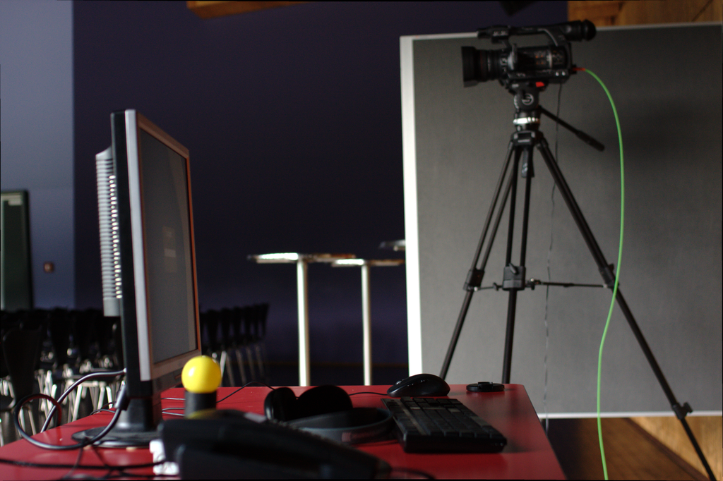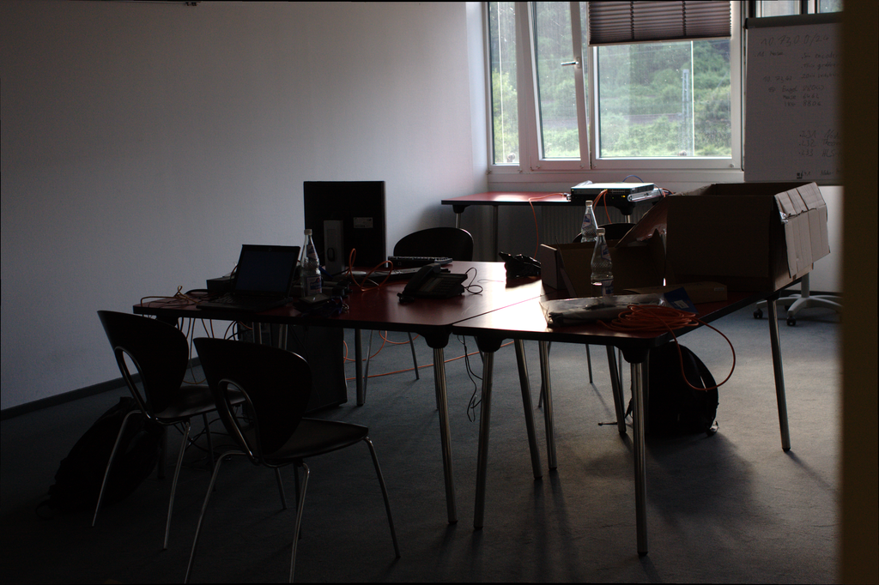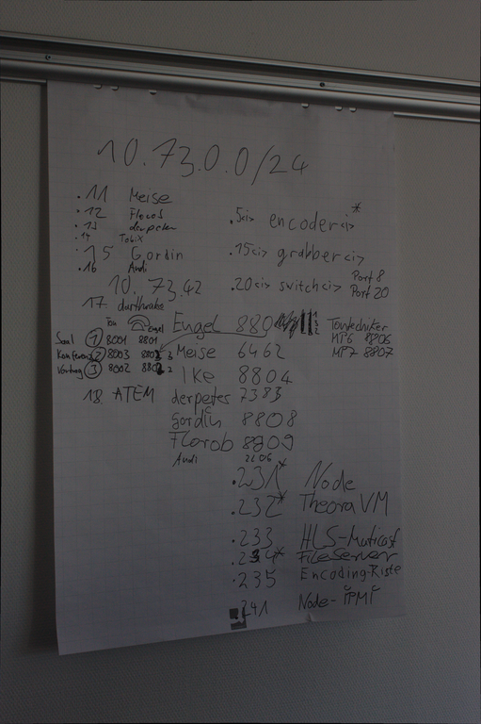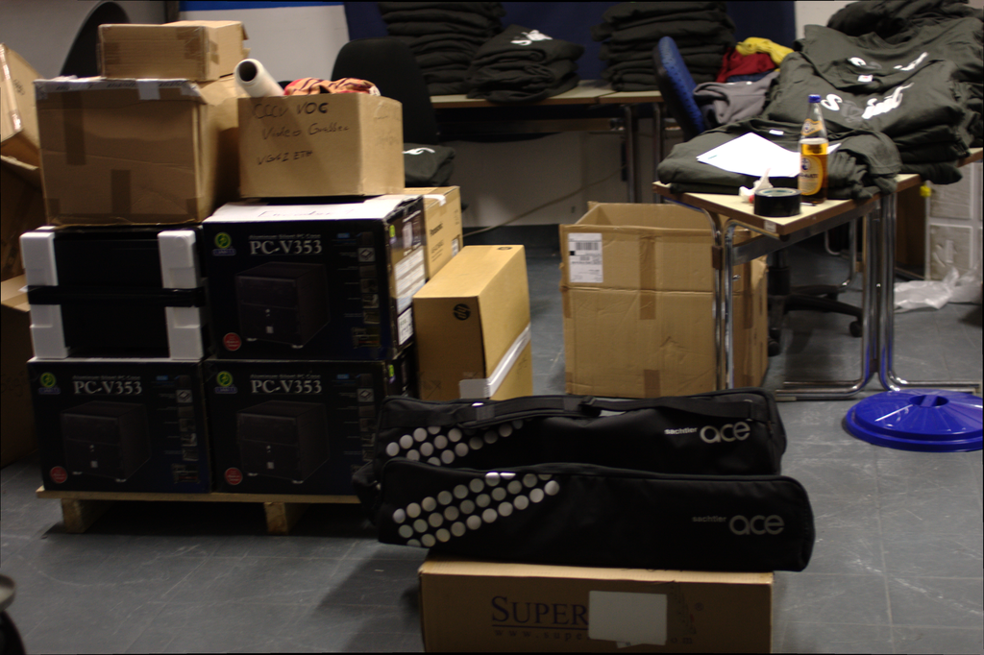

Setup

Hardware
Encoders, cameras and framegrabbers directly at the rooms. Audio is connected via to the 2nd XLR port of the camera (which goes to channel 1 and 2). The camera is connected via SDI to the encoder. The framegrabber is connected to the encoder via ethernet. On the encoder runs a ffmpeg process converting the mjpeg feed from the framegrabber to pal-dv. Recording and switching between the differnet audio and video sources is done with dvswitch.

Settings VGA Broadcaster
- MJPEG with “Default” setting (not “High speed”)
- 25 fps
- no audio
- no recording

