= Artwork == Backgrounds === CCC Curated Contend Stream Design Backgrounds for text intros https://styleguide.rc3.world/RC3%20Style%20Guide%20Essentials.pdf#page=27
e
Side by Side Backgrounds https://styleguide.rc3.world/RC3%20Style%20Guide%20Essentials.pdf#page=26
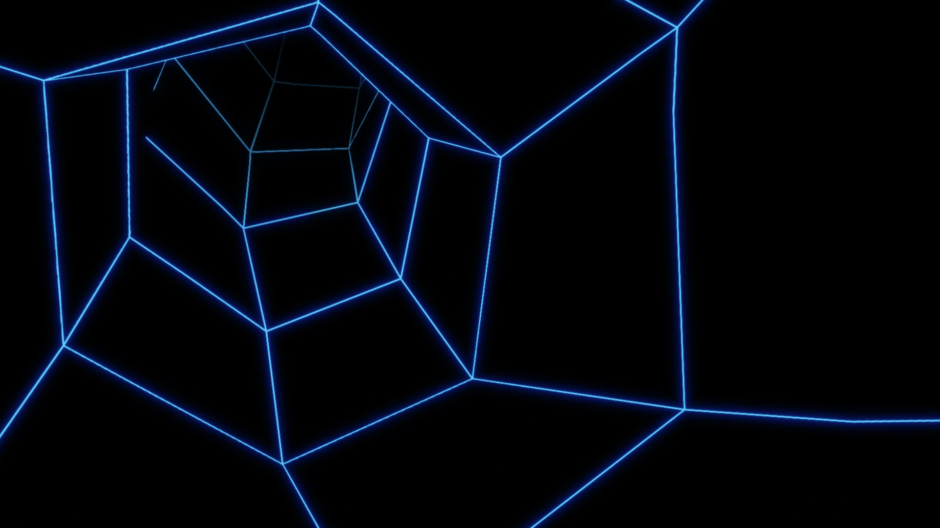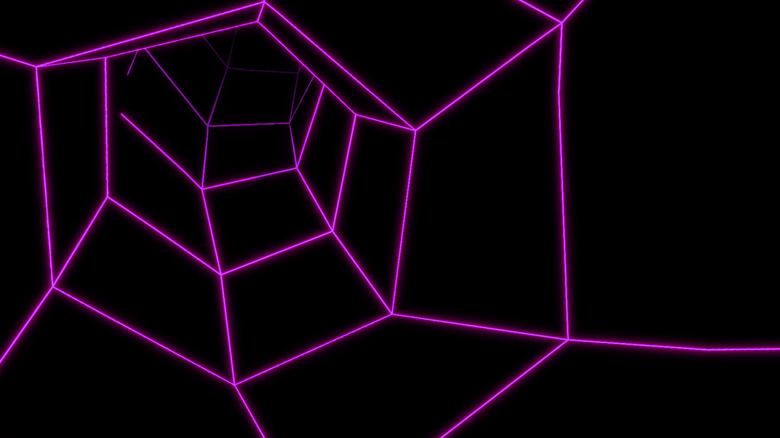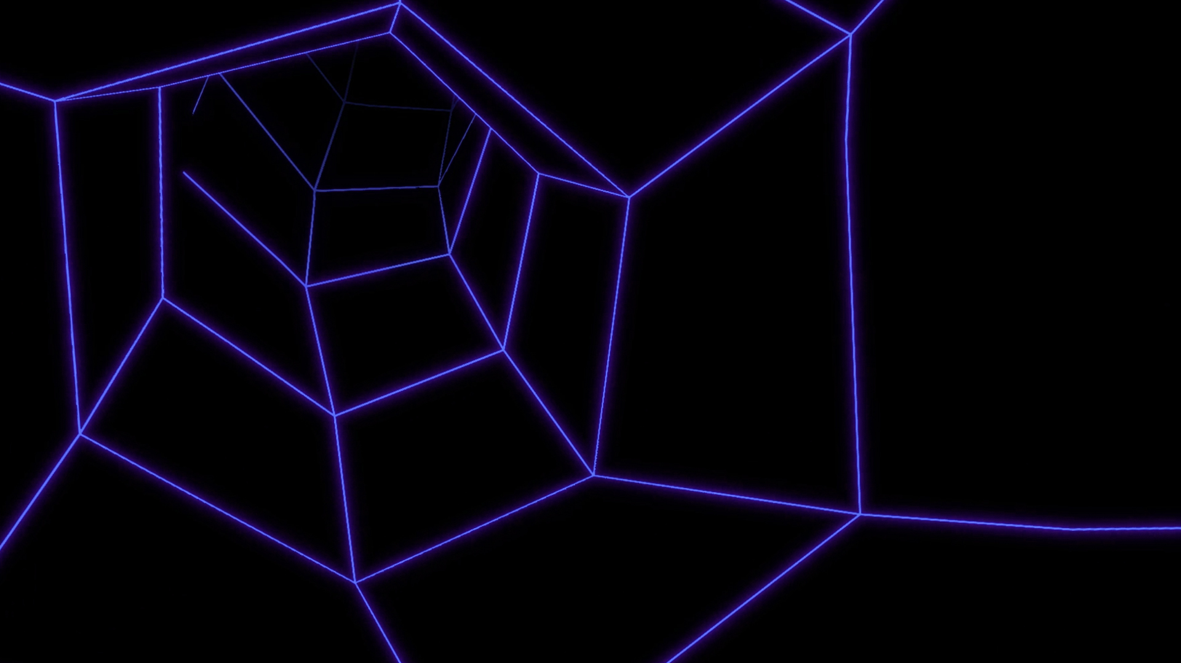
Position Mask (Speaker/Slides) https://styleguide.rc3.world/RC3%20Style%20Guide%20Essentials.pdf#page=26
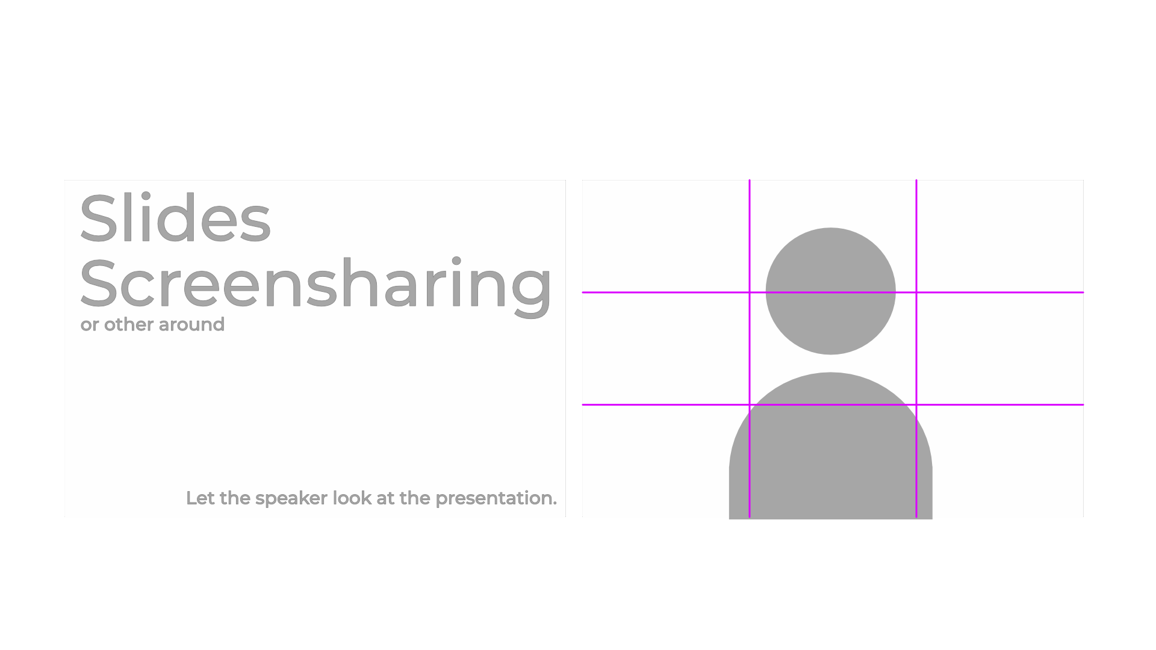
Backgrounds for Greenscreens (Heralds)
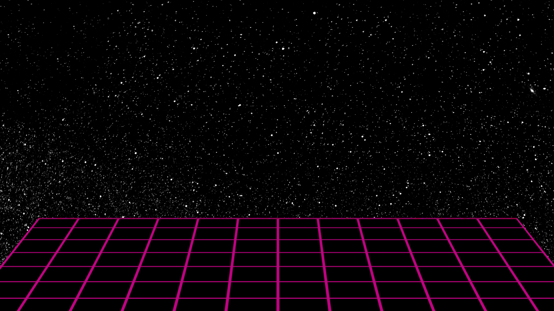
=== Assembly Content rC3
Backgrounds for text intros https://styleguide.rc3.world/RC3%20Style%20Guide%20Essentials.pdf#page=31
assembly_01_intro_ohne_text.mp4
Side by Side Backgrounds https://styleguide.rc3.world/RC3%20Style%20Guide%20Essentials.pdf#page=30
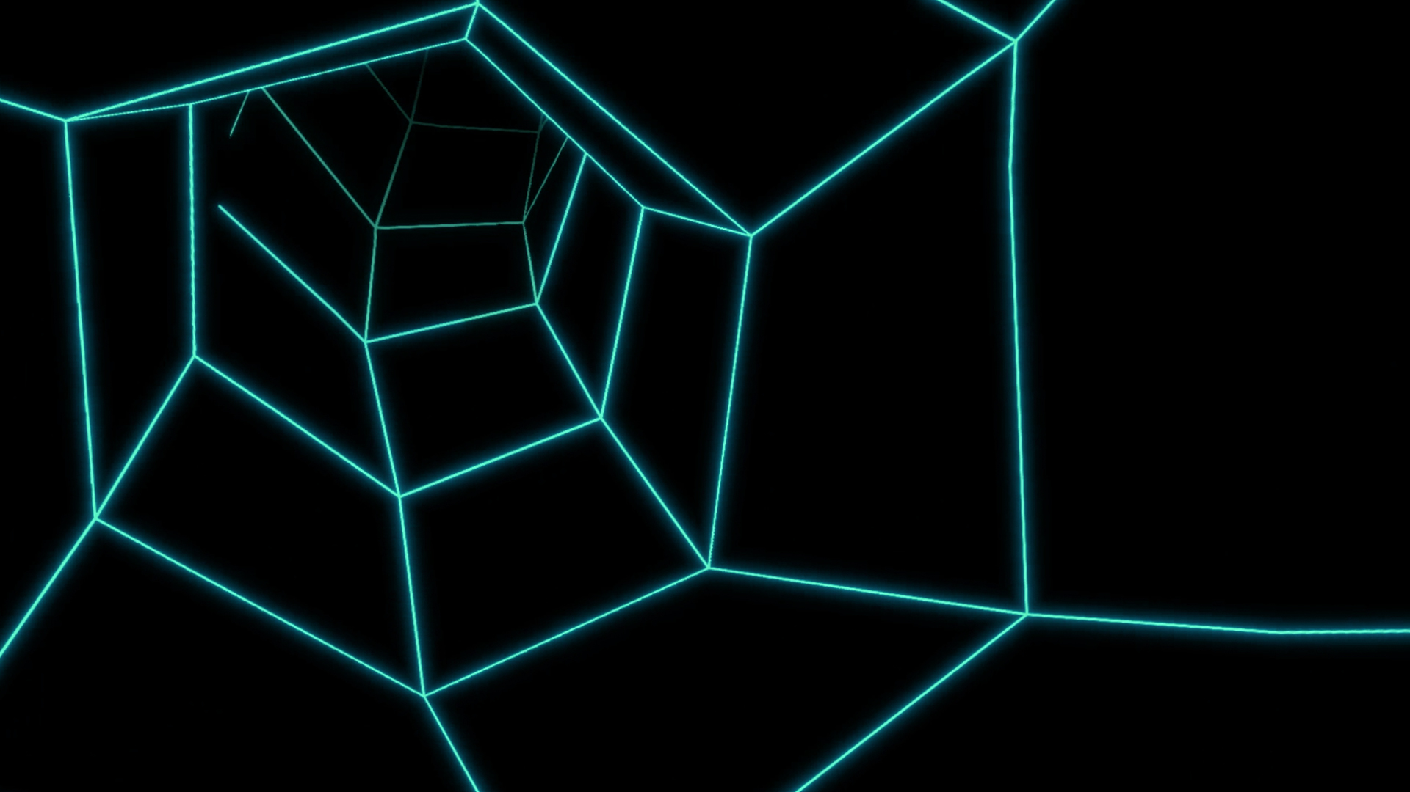
Backgrounds for Greenscreens (Heralds)


