= CCC CampMap
For the CCC Camps 2014 and 2019, c3voc provided a separate OpenStreetMap-Compatible Website/API to manage Camp-Specific information, that does not belong into the official OpenStreetMap:
- NOC Fibers
- Datenklos
- Orga-Containers
- Villages
- Camp-Specific Buildings
This is primarily a planning-utility for VOC, POC, NOC and other *OCs that need to map plan their Infrastucture before the camp – it is not intended to be edited by the public.
The CCC Camp-Map is located at https://maps.c3voc.de/#map=17/53.03122/13.30823&layers=D Although there is an interactive Map on that page, it only showing the CampMap-Data in the „Data“ layer, as we not yet (and probably never) have our own map rendering stack.
== Accessing the Data with JOSM If you do not know if you have an Account or do not remember your Password, go to https://maps.c3voc.de/user/forgot-password and request a new one. This page will explicitly tell you, when your Username is unknown. Please register an Account at https://maps.c3voc.de/user/new then.
Download and Install JOSM.
=== Configure JOSM to use the private API-Server: 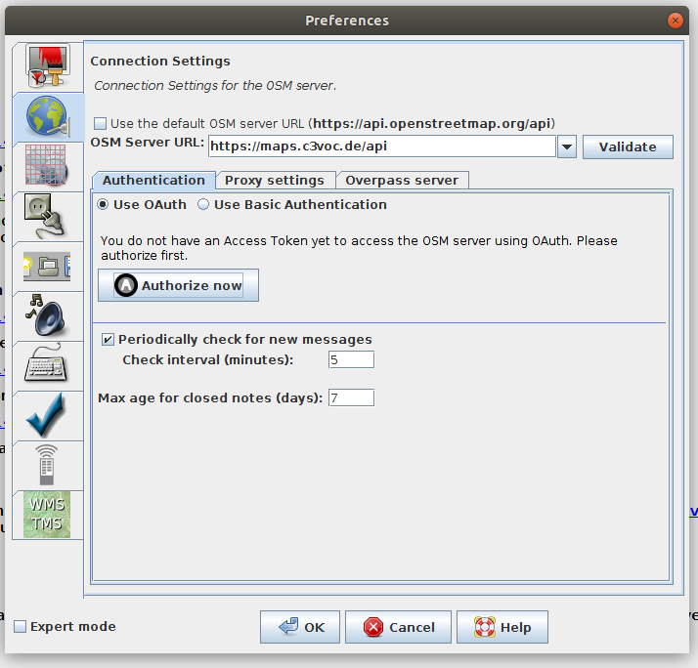
=== Configure the OAuth-Parameters for the private Server: 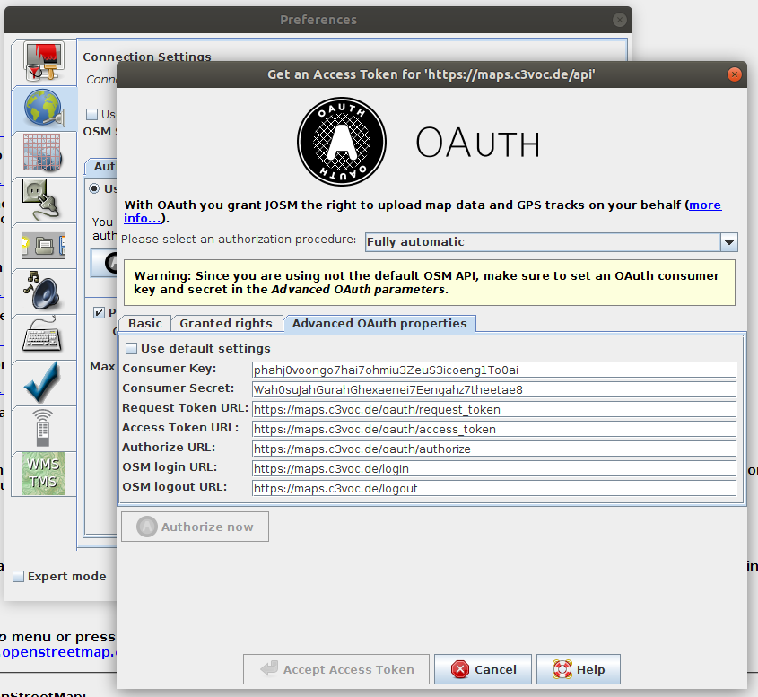
- Consumer Key: phahj0voongo7hai7ohmiu3ZeuS3icoeng1To0ai
- Consumer Secret: Wah0suJahGurahGhexaenei7Eengahz7theetae8
=== Download the complete Camp-Site 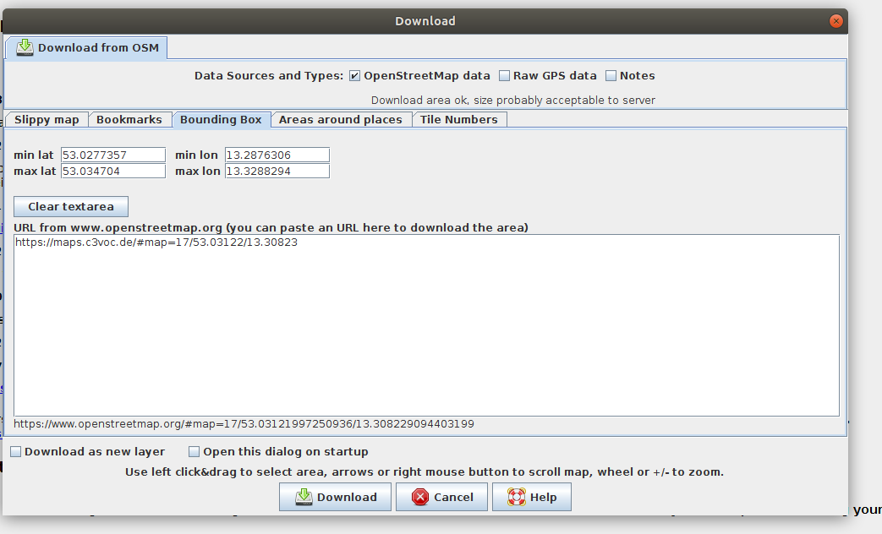
The easiest way to download the complete Camp-Site is by using the Bounding Box function with this Link: https://maps.c3voc.de/#map=17/53.03122/13.30823
=== Modify Map-Data 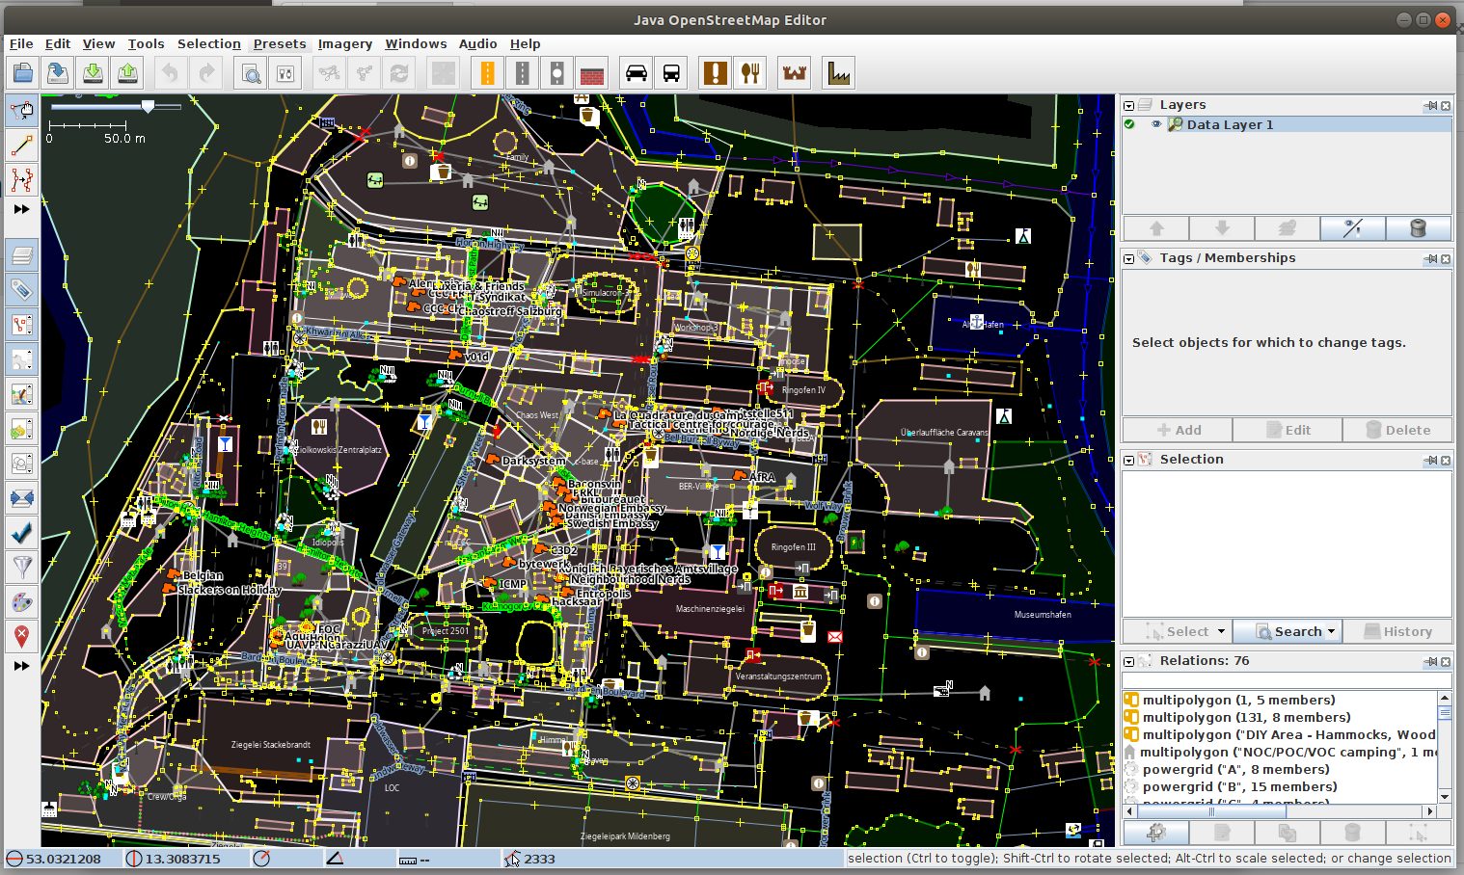
Please remember again, that other *OCs use this in their way to plan their things. Do not change or remove things you do not know what they're for.
== Filter! 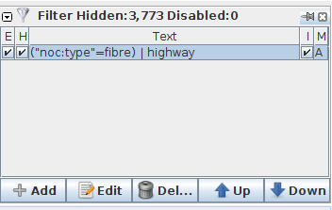 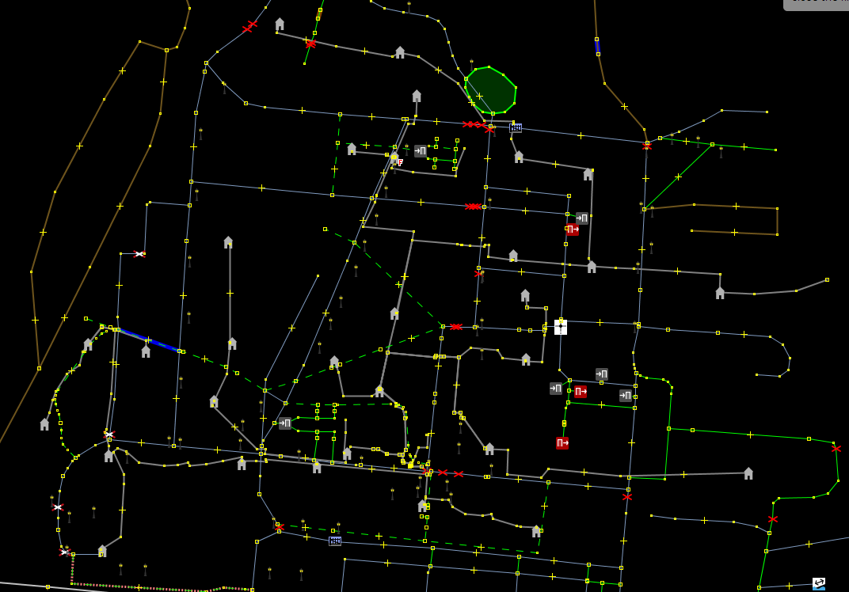
Make excessive use of JOSMs filterfunctionality, here showing only walk-ways and NOC-Fibers,

