Project setup
- Create tracker project (you can also clone a matching project to have prefilled properties)
  - Import schedule.xml
  - Set all master tickets from staging to staged via mass-edit
  - Adjust project properties, recommendations: (full reference at the bottom of the page)
  - Compare project properties with previous instalment of the same event

optimal properties from current project
Replace camp2023 with your chosen tracker project slug.
Meta.Acronym camp2023
Meta.Album Chaos Communication Camp 2023
Meta.License Licensed to the public under http://creativecommons.org/licenses/by/4.0
Meta.Year 2023
Processing.Auphonic.Enable no
Processing.BasePath /video/
Processing.MasterMe.Enable yes
Processing.Path.Intros /video/intros/camp2023
Processing.Path.Outro /video/intros/camp2023/outro.ts
Publishing.Upload.SkipSlaves minion254-1,minion254-2,minion254-3,minion254-4
Publishing.UploadTarget releasing.c3voc.de:/video/encoded/camp2023/
Publishing.Tags <additional tags>
Publishing.Voctoweb.Enable yes
Publishing.Voctoweb.Path /cdn.media.ccc.de/events/camp2023
Publishing.Voctoweb.Slug camp2023
Publishing.Voctoweb.Thumbpath /static.media.ccc.de/conferences/camp2023
Publishing.YouTube.Category 27
Publishing.YouTube.Enable yes
Publishing.YouTube.Playlists <meep>
Publishing.YouTube.Privacy <one of: public, unlisted, private>
Publishing.YouTube.Token <meep>
Record.Container TS
Record.EndPadding 300
Record.Slides yes
Record.StartPadding 300

Worker Filter Examples
# get all non-master tickets
EncodingProfile.IsMaster=no
# get all master tickets
EncodingProfile.IsMaster=yes
# get all recording tickets
EncodingProfile.IsMaster=
# get all tickets in this room.
Fahrplan.Room=Servus.at Lab
Please note that the conditions in the “project to worker group” filter are currently always evaluated with logical OR.
Specifying a property with an empty value, which is often done for EncodingProfile.IsMaster, will match if this property does not exist at all on a ticket. So for EncodingProfile.IsMaster, specifying an empty filter will match on recording tickets which never have this property.
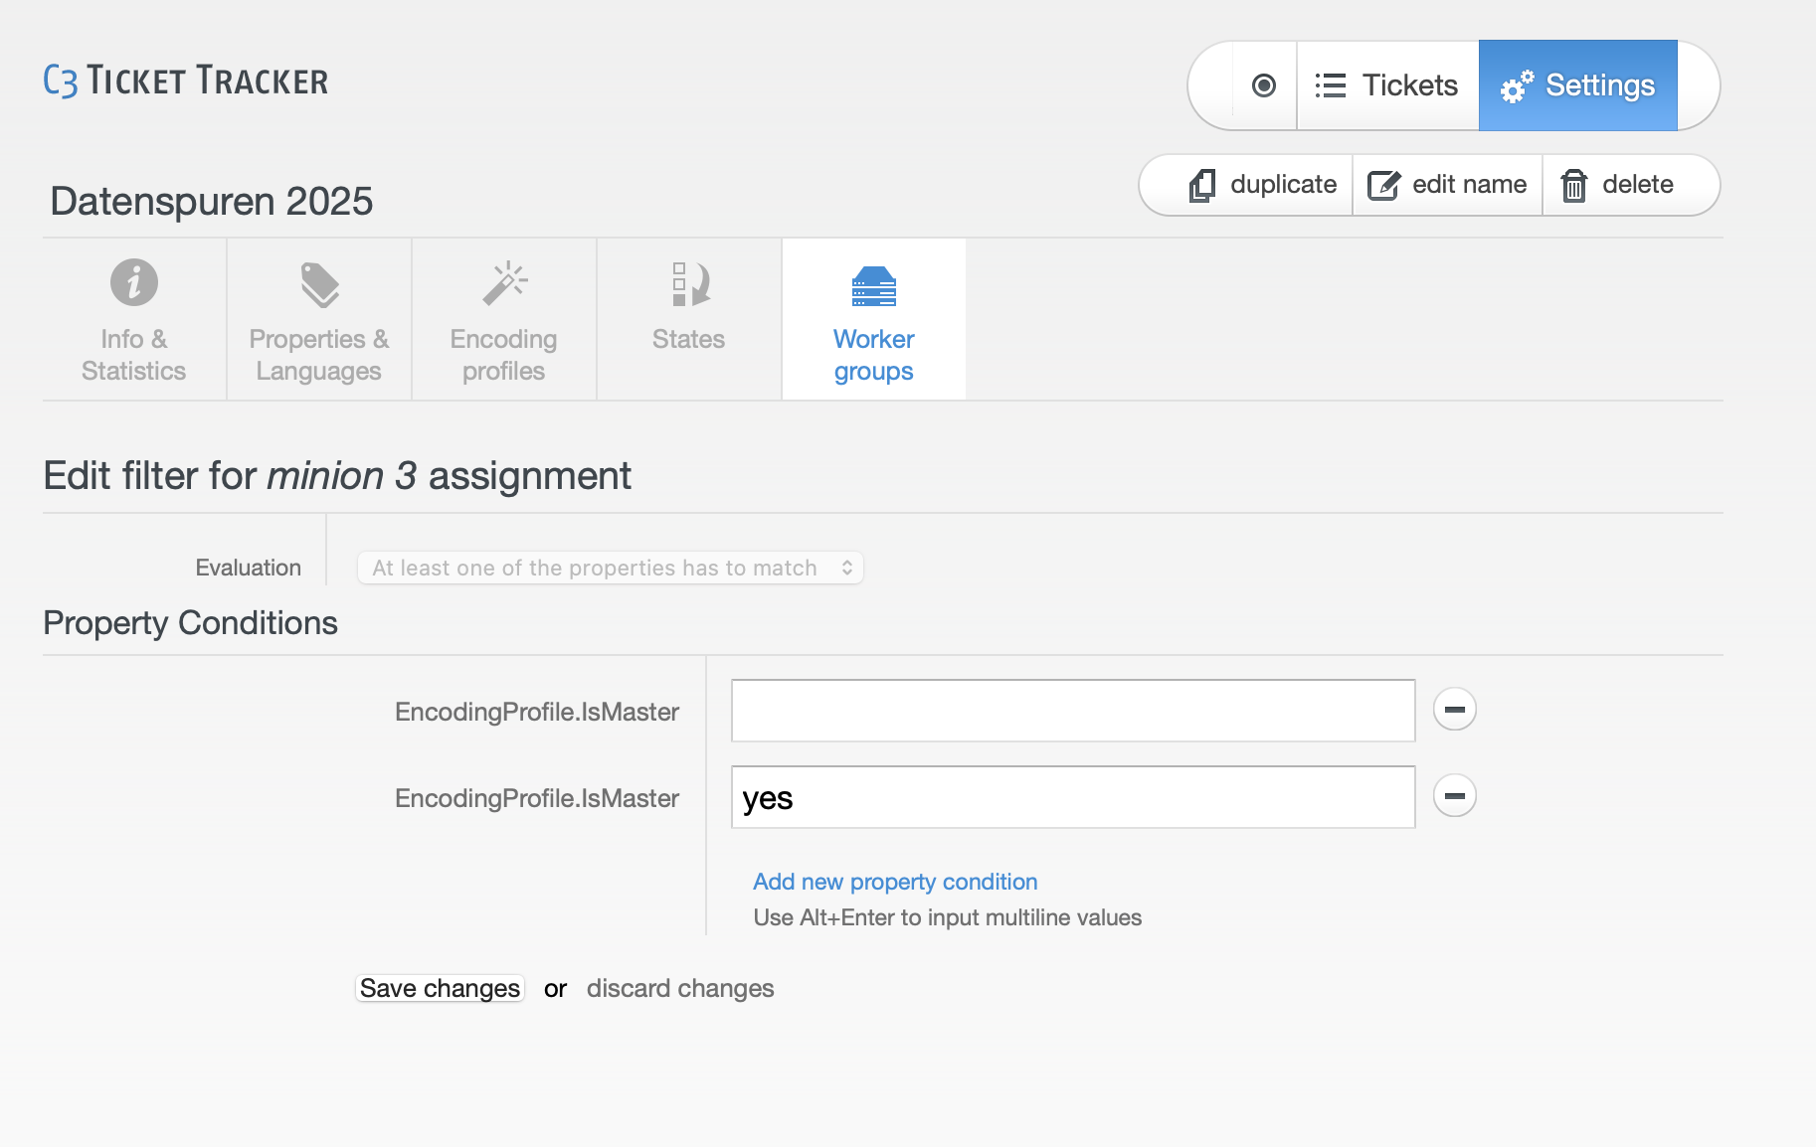

Pipeline setup during event
During event setup of the pipeline, you have to decide if you want leave the MPEG TS snippets only on the recording cubes or also rsync them to a central storage:

Simple: single-room setup (Variant A)
This variant is practical if you have only one room, or at least one release encoder (aka Minions) for each recording encoder PC. When using this variant with multiple rooms in one Tracker project (like at JEV22), you also have to set room filters in the tracker worker queues.
For every worker:
- set EncodingProfile.IsMaster = yes to avoid encoding all sub formats
- (set room filters in tracker e.g. Fahrplan.Room = Foobar, but this cannot be used at the same times as the above, see the warning below)
For every recoding cube:
- start tracker worker: sudo systemctl start crs-worker.target
For each minion:
- mount filesystems from encoder cube: sudo crs-mount <storage location>
- start tracker scripts for encoding: sudo systemctl start crs-encoding.service
Since tracker filters are joined via OR and not AND, this setup cannot be extended to multiple rooms without hacks if you want to e.g. limit on-site encoding to master formats. Use the CRS_ROOM filter in bundlewrap if you need both tracker filters and room-specific encoding workers.

centralised storage (rsync) (Variant B)
This variant is typically used for events with more than one room.
For bigger events we use the dedicated storage server in the event server rack, for smaller events one of the minions is typically sufficient. If you use a minion as storage machine, you might want to configure 10.73.0.2 (aka storage.lan.c3voc.de) as secondary IP address to make things easier:
sudo ip a add dev br0 10.73.200.24/16
Each recording encoder exposes the files via rsyncd, which are pulled by an rsync process running on this storage machine.
For each encoderX start rsync on the storage machine:
sudo systemctl start rsync-from-encoder@encoderX.lan.c3voc.de
If you use a minion as storage machine, you have start the tracker manually (on storage.lan.c3voc.de they are started by default):
sudo systemctl start crs-worker.target
which starts
- crs-recording-scheduler (A)
- crs-mount4cut.service (B)
- crs-cut-postprocessor (C)
- crs-encoding0, crs-encoding1 (D)
- crs-postencoding (E)
- crs-postprocessing (F)

Minion setup
To allow get additional release encoding workers on the (other) minions, you need to connect to these an mount the storage machine first:
ssh minionX.lan.c3voc.de
sudo crs-mount <storage location>
After mounting, you can start the tracker encoding workers:
sudo systemctl start crs-encoding0.service
The virtual minion's living in event colo case automatically mount storage.lan.c3voc.de via CIFS and start their worker scripts. You usually do not need to touch them.

Encoder PCs as release encoding workers
At small events, when all talks are finished for today, you can use the recording encoder PCs to encode master MP4 files.
First – stop voctocore:
sudo systemctl stop voctomix2-voctocore
The rest is very similar to above, but with different mounts so /video/capture is not hidden:
sudo mount -t cifs -o uid=voc,password= //storage.lan.c3voc.de/fuse /video/fuse
sudo mount -t cifs -o uid=voc,password= //storage.lan.c3voc.de/video/intros /video/intros
sudo mount -t cifs -o uid=voc,password= //storage.lan.c3voc.de/tmp /video/tmp
sudo mount -t cifs -o uid=voc,password= //storage.lan.c3voc.de/encoded /video/encoded

decentralised pipeline aka "even more samba" (Variant C)
The “decentralized pipeline” should not be used by inexperienced users. Use the information above to find out how to get this variant working, then adjust/improve the documentation here.
Similar to variant B, but extended to work with multiple rooms. Instead of using rsync, recorded snippets remain on the encoding cubes and /video/fuse/$event/$room are exposed via samba to the minions, while the encoded and tmp files live on one “central” minion; all other minions mount /video/encoded and /video/tmp from the primary minion [reasoning: the tracker cannot guarantee that the machine which encoded a talk also does the postprocessing (upload) step, so all minions have to see the same files].
Tracker filters have to be set only for the recording cubes, minions do not require any filters (but on smaller events without many minions, a EncodingProfile.IsMaster=yes filter can be a good idea, so sub formats won't crowd out the queues — they can always be encoded off-site later).
On recording encoder PCs start the following systemd units:
- crs-recording-scheduler
- crs-mount4cut
- crs-cut-postprocessor
On all minions, including the one acting as storage, do
mkdir -p /video/fuse/$event/{$room1, $room2, ..}
mount.cifs -o uid=voc,password= {//$encoder1.lan.c3voc.de,}/video/fuse/$event/$room1
mount.cifs -o uid=voc,password= {//$encoder2.lan.c3voc.de,}/video/fuse/$event/$room2
...
On all minions except the one acting as storage, also mount:
mount.cifs -o uid=voc,password= //$storage.lan.c3voc.de/encoded /video/encoded
mount.cifs -o uid=voc,password= //$storage.lan.c3voc.de/tmp /video/tmp
mount.cifs -o uid=voc,password= {//$storage.lan.c3voc.de,}/video/intros
Finally on all minions, including the one acting as storage, start the following systemd units:
- crs-encoding
- crs-postencoding
- crs-postprocessing

Old example with systemd units and case 1 and 5, which was used during jev22 in Munich:
optional: configure 10.73.0.2 (aka storage.lan.c3voc.de) on the master minion as secondary ip
sudo ip a add dev br0 10.73.200.24/16
on recording cubes, mount or copy the intros from their source – here storage.lan.c3voc.de
sudo mount -t cifs -o password= {//storage.lan.c3voc.de,}/video/intros
sudo systemctl start crs-recording-scheduler # A
sudo systemctl start crs-mount4cut # B
sudo systemctl start crs-cut-postprocessor # C
# check if everything is running as expected – you might have to disable/stop the other CRS workers D-F
sudo systemctl status -n 0 crs-*
on master minion (in this example storage.lan.c3voc.de)
mkdir -p /video/fuse/jev22/{Ahlam,Bhavani}
mount -t cifs -o password= {//encoder1.lan.c3voc.de,}/video/fuse/jev22/Ahlam
mount -t cifs -o password= {//encoder5.lan.c3voc.de,}/video/fuse/jev22/Bhavani
sudo systemctl start crs-encoding # D-encoding
sudo systemctl start crs-postencoding # E-postencoding-auphonic
sudo systemctl start crs-postprocessing # F-postprocessing-upload
# check if everything is running as expected – you might have to disable/stop the other CRS workers A-C
sudo systemctl status -n 0 crs-*
(ensure that samba is installed on this master minion aka storage)
on other minions
mkdir -p /video/fuse/jev22/{Ahlam,Bhavani}
mount -t cifs -o uid=voc,password= {//encoder1.lan.c3voc.de,}/video/fuse/jev22/Ahlam
mount -t cifs -o uid=voc,password= {//encoder5.lan.c3voc.de,}/video/fuse/jev22/Bhavani
mount -t cifs //storage.lan.c3voc.de/encoded /video/encoded
mount -t cifs -o password= //storage.lan.c3voc.de/encoded /video/encoded
mount -t cifs -o password= //storage.lan.c3voc.de/tmp /video/tmp
mount -t cifs -o password= {//storage.lan.c3voc.de,}/video/intros

Old example with custom screenrc and case 5 and 6:
on recording cube, without intros either copy or mount the intros from their source
sudo mount -t cifs -o password= {//storage.lan.c3voc.de,}/video/intros
cd /opt/crs/tools/tracker3.0/
sudo ./start screenrc-pipeline # with steps A, B and C
on master minion (in this example minion5)
mount -t cifs -o password= //encoder5.lan.c3voc.de/video/fuse/podstock2019/Aussenbuehne /video/fuse/podstock2019/Aussenbuehne
mount -t cifs -o password= //encoder6.lan.c3voc.de/video/fuse/podstock2019/Innenbuehne /video/fuse/podstock2019/Innenbuehne
mount -t cifs -o password= //encoder6.lan.c3voc.de/video/intros /video/intros
cd /opt/crs/tools/tracker3.0/
sudo ./start screenrc-pipeline # with steps D, E, F
(ensure that samba is installed on this master minion)
on other minions
mount -t cifs -o password= {//encoder5.lan.c3voc.de,}/video/fuse/podstock2019/Aussenbuehne
mount -t cifs -o password= {//encoder6.lan.c3voc.de,}/video/fuse/podstock2019/Innenbuehne
mount -t cifs //storage.lan.c3voc.de/encoded /video/encoded
mount -t cifs -o password= //storage.lan.c3voc.de/encoded /video/encoded
mount -t cifs -o password= //storage.lan.c3voc.de/tmp /video/tmp
mount -t cifs -o password= {//storage.lan.c3voc.de,}/video/intros
cd /opt/crs/tools/tracker3.0/
sudo ./start screenrc-encoding-only # only step E

