CRS Concepts
The C3 Ticket Tracker enables the (semi-)automated recording, editing & release of multilingual videos. In order to complete a release successfully, certain project settings must be configured and a few of the state transitions must be operated manually:

User Roles
User accounts can have different roles depending on what the user should be able to do:
- User - can cut and edit tickets
- Restricted - can only use already defined actions and can't define new actions
- Superuser - can edit profiles and (re)import fahrplan
- Admin
more details on https://github.com/crs-tools/tracker/blob/master/src/Config/AccessControl.php
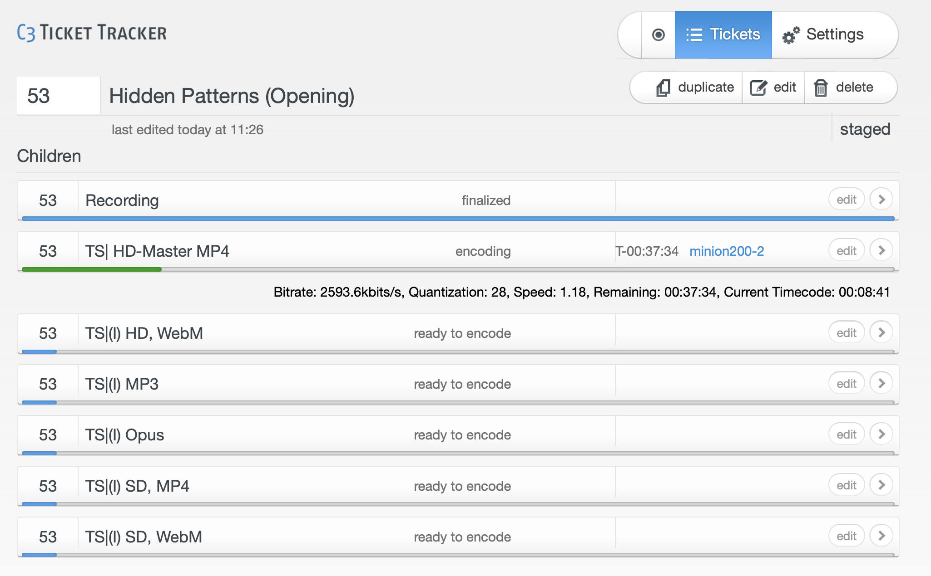

Ticket types and hierarchy
One of the really good features of the C3 tracker is that propertyies are inherited through the hierarchy:
- Project settings (Conference or Series)
  - Meta ticket (Parent with Fahrplan-ID & -Metadata)
    - Recording ticket (Language, etc)
      - Main encoding ticket (MP4)
      - additional encoding tickets, e.g. WebM, MP3, Opus, SD formats, etc.

Ticket states and pipeline
For each ticket type, the tracker has a predefined set of states, which can be enabled and disabled on an per project basis. Here is an example workflow with only one manual checking step:
This allows quite flexible pipelines, which are described in more detail in Project setup – for now lets focus on a typical one:
Let's look into the steps done by worker scripts

Recording

Worker A: Recording Scheduler
script-A-recording-scheduler.pl
Schedules and transitions tickets from scheduled via recording to recorded, optionally filters by room. Skips opt-out events, but does not perform any real task besides transitioning the recording ticket.
- Inputs: CRS ticket in scheduled state
- Outputs: Ticket moved to recording or skipped
- Notes: Uses CRS_ROOM, Record.StartedBefore, and Record.EndedBefore filters
The actual recording is done by a bundlewrap configured systemd unit on the encoder which writes TS-Schnipsel to /video/capture/<conference-acronym>/<room>/, which are rsynced to storage. The “Schipsel” file names include the room name and recording timestamp as follows:
<room>-YYYY-MM-DD_HH-MM-SS.<extension>

Worker B: Create virtual project files
script-B-mount4cut.pl
Mounts raw video segments via FUSE. Checks and sets cut marks, stores metadata like duration and framerate.
- Inputs: Ticket in recording → preparing state
- Outputs: FUSE mount created and cut marks optionally stored
- Notes: Supports DV and TS formats

Manual task by VOC crew: Cut
see cutting
The cutting process requires the operator to set start and end marks, using MLT-Video-Editor like Shotcut/Kdenlive but tooling accepts frame numbers via CLI. If your player does not show frame numbers you can approximate with the formula seconds * 25 assumed you have 25 frames per second. Note that this means you cut per second not per frame!
c3_tracker_-_schnitt_mit_kdenlive.mp4
- Usage video YT link (german)
- TODO: CCCamp15 Recording / Postprocessing integrieren

Worker C: Finalise recording ticket
script-C-cut-postprocessor.pl
Validates cut marks, adds intro/outro clips if defined, and calculates cut durations. Fails tickets with incomplete data.
- Inputs: Ticket in cut state
- Outputs: Ticket in finialized state, updated with durations and metadata
- Notes: Verifies intro/outro file paths and presence
Naming for intro and outro, all in /video/intros/<conference-acronym>/:
- Intro <integer-event-id>.ts
- Outro: outro.ts

Encoding

Worker D: Encoding
script-D-encoding.pl
Runs encoding tasks from job XML. Skips if Voctomix is detected. Supports VAAPI acceleration and logs execution times.
- Inputs: Ticket in ready to encode state, XML jobfile with ffmpeg commands
- Outputs: Encoded media file(s), ticket state updated to encoded
- Notes: Uses CRS::Executor and task-type detection

Worker E: Postencoding
script-E-postencoding-auphonic.pl
Runs audio processing and remuxing. Can optionally delegate to Auphonic for audio leveling and rendering.
- Inputs: Ticket in encoded state
- Outputs: Ticket in postencoded state, media file (MP4, …) with updated audio tracks and metadata
- Notes: Supports audio hash checking and production reuse

Manual task by VOC crew: Check
see checking

Worker F: Upload from Encoder (local) to Releasing host
script-F-postprocessing-upload.pl
Uploads processed files to the target via ssh from encoder/storage to releasing.c3voc.de. Can skip uploads based on host config.
- Inputs: Ticket in postprocessing state
- Outputs: Files pushed to publishing target
- Notes: Validates file presence, honors opt-out and skip-hosts

Publishing
https://github.com/voc/voctopublish


