Multiviews

rC3_21
- https://live.chaoswest.tv/4k_monitor/

Web
Browser, können oft maximal 6 Verbindungen – kann man bei Firefox via about:config Option network.http.max-persistent-connections-per-server entsprechend hochsetzen.
- http://streaming.media.ccc.de/<$konferenz>/multiview
  - alle Streams inklusive Subformate, hängt Erfahrungsweise aber nach ein paar Stunden auf
- http://voc.marudor.de 404
  - WebM SD mit Audio-Bars

Nativ

multiview-monitor
https://github.com/voc/multiview-monitor
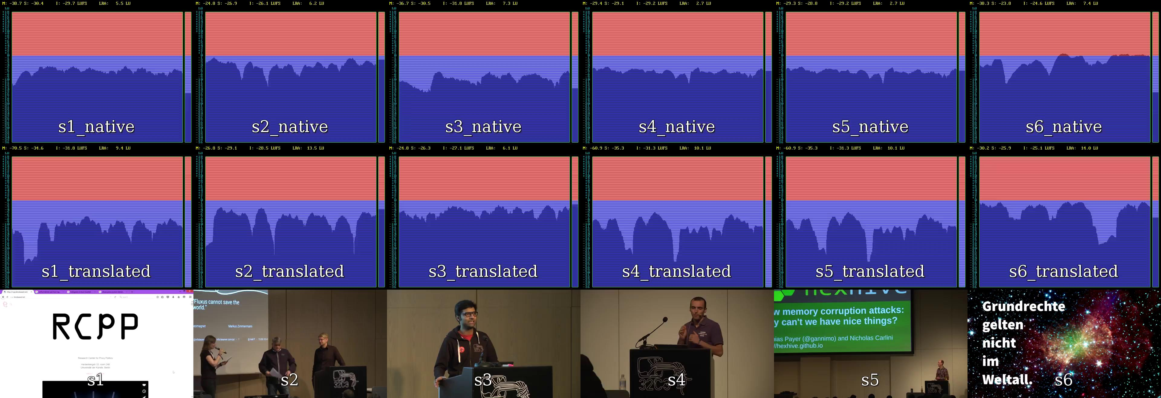

mit i3 und mpv bei der froscon16
~/.config/mpv/mpv.conf
hwdec=auto
start-streams-vertical.sh
#!/bin/bash
export DISPLAY=:0
i3-msg workspace mpv
mpv --no-audio --really-quiet rtmp://10.73.1.3:1935/stream/s1_native_hd &
P1=$?
i3-msg splith
sleep 3
mpv --no-audio --really-quiet rtmp://10.73.2.3:1935/stream/s2_native_hd &
P2=$?
sleep 3
mpv --no-audio --really-quiet rtmp://10.73.3.3:1935/stream/s3_native_hd &
P3=$?
sleep 3
mpv --no-audio --really-quiet rtmp://10.73.4.3:1935/stream/s4_native_hd &
P4=$?
sleep 10
i3-msg focus parent
sleep 3
i3-msg splitv
sleep 3
mpv --no-audio --really-quiet rtmp://10.73.5.3:1935/stream/s5_native_hd &
P5=$?
sleep 10
i3-msg splith
mpv --no-audio --really-quiet rtmp://10.73.6.3:1935/stream/s6_native_hd &
P6=$?
sleep 10
mpv --no-audio --really-quiet rtmp://10.73.7.3:1935/stream/s7_native_hd &
P7=$?
read
kill -9 $P1
kill -9 $P2
kill -9 $P3
kill -9 $P4
kill -9 $P5
kill -9 $P6
kill -9 $P7
export DISPLAY=:0
chromium --new-window https://streaming.media.ccc.de/foss4g-2016/schedule
chromium --new-window --disable-web-security --user-data-dir index.html
(Chromium wegen Hardwarebeschleunigung, index.html ist modifizierte version von voc.marudor.de bei der die zweite Hälfte der Streams von live.dus.c3voc.de gezogen wird um das 6er connection limit pro Server zu umgehen.)
Zwischen i3 workspaces hin und her schalten
while /bin/true; do for i in 1 3; do i3-msg workspace $i; sleep 10; done; done

mit ffmpeg
#/bin/bash
o='rtmp://127.0.0.1/stream/loudness'
for i in s{1,2,3,4,5,6,41,42}
do
if [[ ! -e /tmp/fifo${i} ]];
then
mkfifo /tmp/fifo${i};
fi
ffmpeg -hide_banner -v warning -y \
-i "http://cdn.c3voc.de/${i}_native_sd.webm" \
-filter_complex "nullsrc=size=640x840 [base];
[0:v] scale=640:360, fps=15 [scaled];
[0:a] ebur128=video=1:meter=18:size=640x480 [ebur][a1];
[ebur] fps=15 [v1];
[a1] aformat=sample_fmts=fltp:sample_rates=44100:channel_layouts=stereo [audio];
[base][v1] overlay=shortest=1 [tmp1];
[tmp1][scaled] overlay=shortest=1:y=480 [ov];
[ov] drawtext=fontcolor=white:x=200:y=50:fontsize=128:fontfile=/usr/share/fonts/truetype/dejavu/DejaVuSansMono.ttf:text=${i} [out]" \
-map "[out]" -c:v rawvideo -pix_fmt yuv420p \
-map "[audio]" -c:a pcm_s16le \
-f matroska "/tmp/fifo${i}" &
#echo $! > /tmp/fifo${i}.pid
done
ffmpeg -hide_banner -v warning -y -fflags +genpts -flags +global_header \
-thread_queue_size 1024 -i /tmp/fifos1 \
-thread_queue_size 1024 -i /tmp/fifos2 \
-thread_queue_size 1024 -i /tmp/fifos3 \
-thread_queue_size 1024 -i /tmp/fifos4 \
-thread_queue_size 1024 -i /tmp/fifos5 \
-thread_queue_size 1024 -i /tmp/fifos6 \
-thread_queue_size 1024 -i /tmp/fifos41 \
-thread_queue_size 1024 -i /tmp/fifos42 \
-filter_complex "
[0:a][1:a][2:a][3:a][4:a][5:a][6:a][7:a] amix=inputs=8 [audio];
nullsrc=size=2560x1680 [base];
[base][0:v] overlay=shortest=1 [tmp1];
[tmp1][1:v] overlay=shortest=1:x=640 [tmp2];
[tmp2][2:v] overlay=shortest=1:x=1280 [tmp3];
[tmp3][3:v] overlay=shortest=1:x=1920 [tmp4];
[tmp4][4:v] overlay=shortest=1:x=0:y=840 [tmp5];
[tmp5][5:v] overlay=shortest=1:x=640:y=840 [tmp6];
[tmp6][6:v] overlay=shortest=1:x=1280:y=840 [tmp7];
[tmp7][7:v] overlay=shortest=1:x=1920:y=840, fps=15 [out]" \
-map "[out]" -s 1280x800 \
-c:v libx264 \
-maxrate:v:0 2000k -bufsize:v:0 8192k -crf:0 21 \
-pix_fmt:0 yuv420p -profile:v:0 main -g:v:0 15 \
-preset:v:0 veryfast \
-map "[audio]" \
-c:a aac -b:a 96k -ar 44100 \
-y -f flv ${o}
killall ffmpeg
exit

