Server Case (C)
Detailed documentation of this case is kept in netbox and should be kept up to date: NetBox: Rack "Event-Server" / NetBox: Cluster "Event-Server"
This case contains hardware that should be placed at the event colo or another well connected place.
Measurements (guessed): Length 102cm, width 60cm, height 77cm.
Weight: ~140 kg
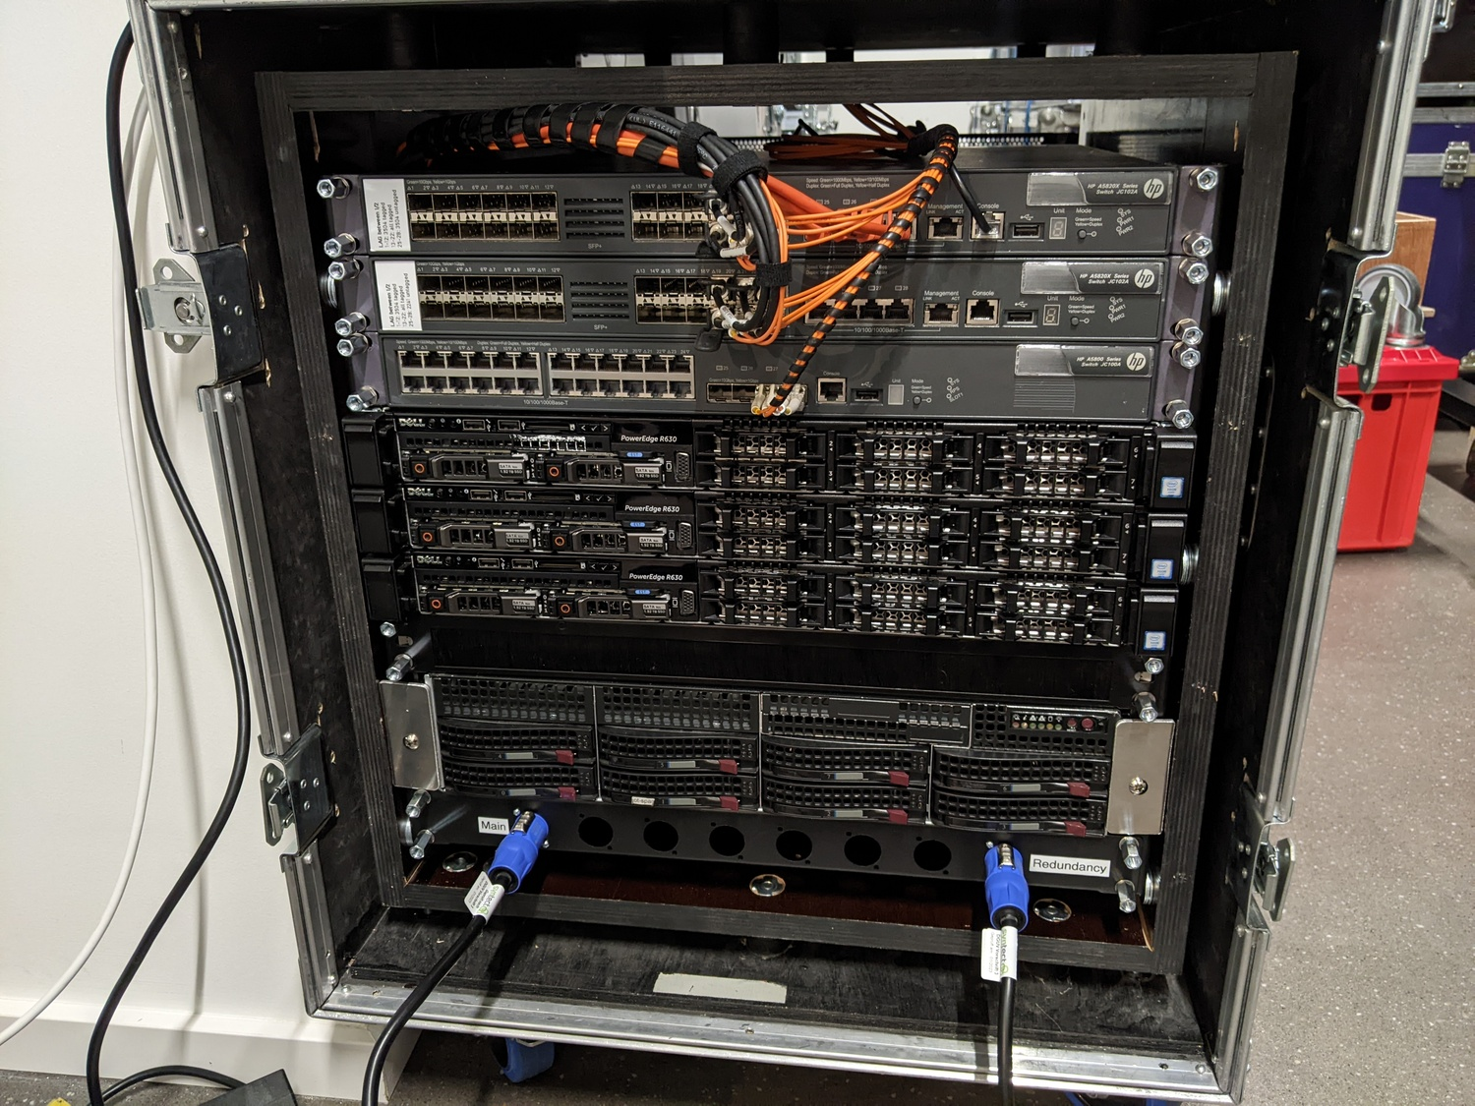Servercase front
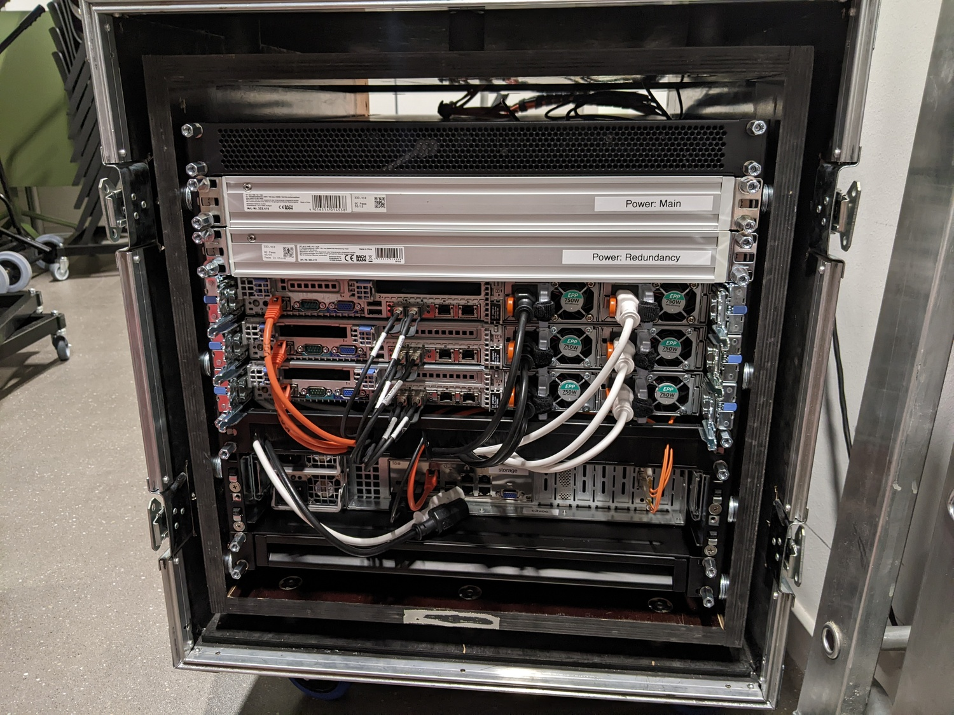Servercase back
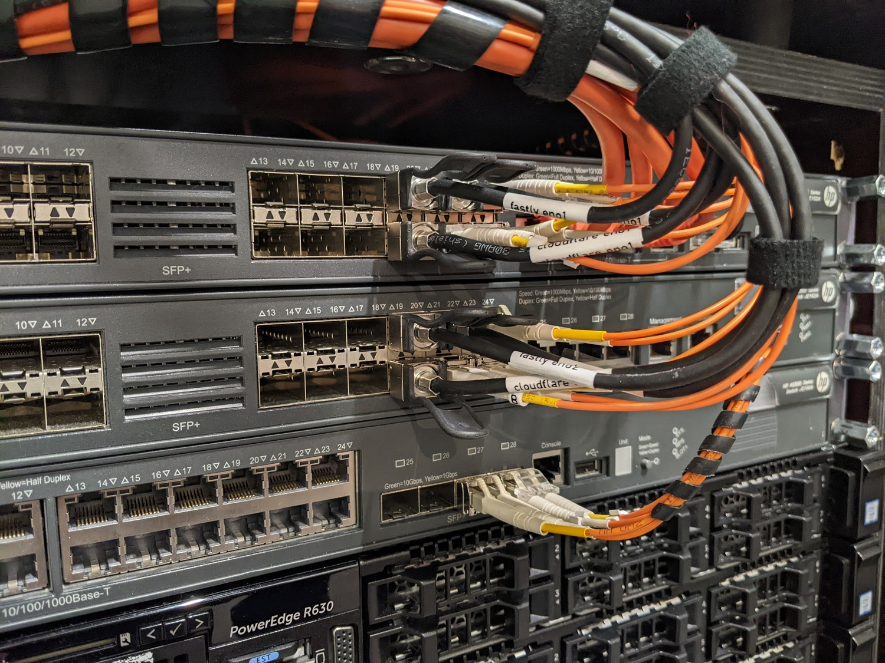Servercase, detail switch-connections
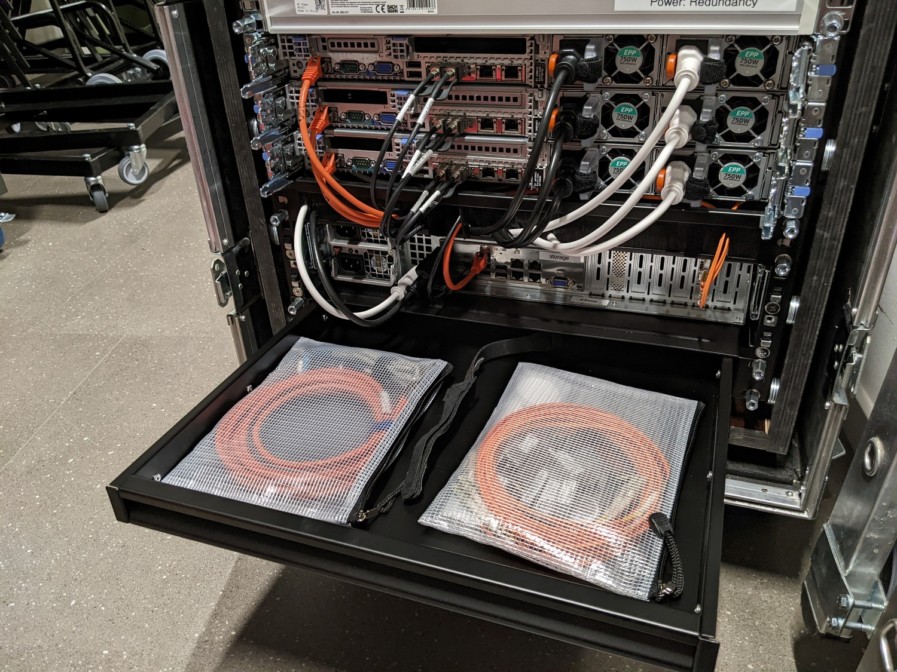Servercase, detail back with open drawer

