Chaos Communication Camp 2011

Overview
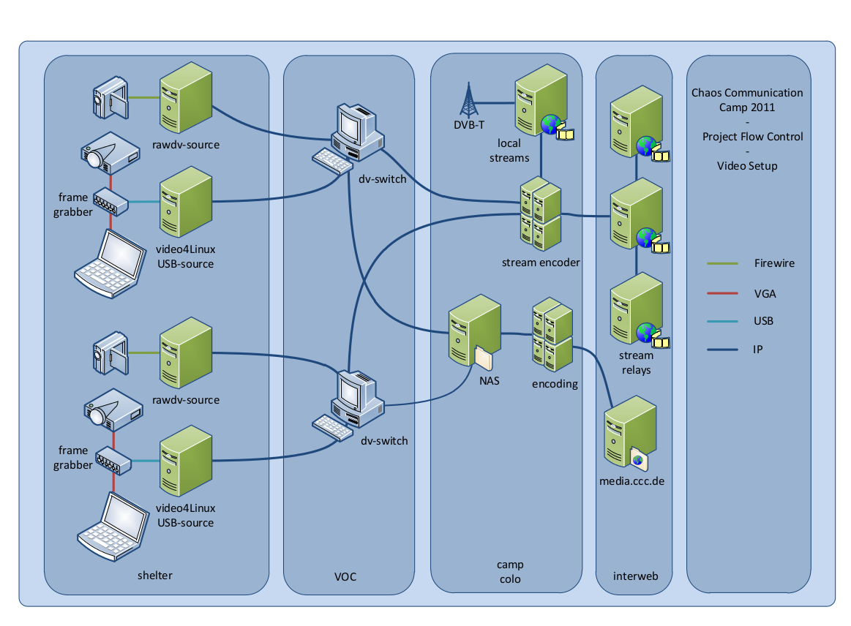
more information on https://orga.cccv.de/camp/2011/wiki/index.php/Documentation/ (internal)

Who
- derpeter
- andi
- meise
- florolf
- qchn
- deborah
- Tec

